Dear Hanna Pellerin,

The Fast Pedal Engineers are writing to express how our plan of action was successful in the annual Acadiana 500 Tricycle Race. As the primary goal of this project is to design and manufacture a tricycle, meeting all design requirements, in order to race in the relay event, the team did so among two phases. Phase 1, or Fall 2024, consisted of the design component of meeting the main goal; Three tricycle designs were created and one, out of the three, was chosen to be the design to be manufactured in Phase 2, or Spring 2025. Phase 2 focused on assembling the chosen design, based on reused and manufactured parts, and racing on the built trike to prove the design’s effectiveness. As the plan of action over Phase 1 and 2 encompassed performing research on the manufacturing process of tricycle, sourcing all materials, creating tricycle designs using SolidWorks, performing an FEA analysis on the chosen design, and manufacturing and assembling the final tricycle, the team was successful in completing all primary tasks due to being awarded first place at the race event. Receiving first place at the Acadiana 500 Tricycle Race was not only rewarding due to the work done over the past two semesters, but it also proved the Fast Pedal Engineers’ tricycle was a suitable design, as well as being precisely manufactured. The team is proud to have made the final chosen design a reality and to have won first place at the relay racing event.

Sincerely,

Fast Pedal Engineers

**Final Report**

MCHE 484: Engineering Projects II

Spring 2025

**“Fast Pedal Engineers”**

Submitted to: Dr. Yonas Niguse

Tricycle Design and Fabrication: Acadiana 500 Tricycle Race

|  |  |
| --- | --- |
| Andre Signoret Department of Mechanical Engineering  University of Louisiana at Lafayette Lafayette, LA 70504 [C00487417@louisiana.edu](mailto:C00487417@louisiana.edu) | Katie Kaliszeski Department of Mechanical Engineering  University of Louisiana at Lafayette Lafayette, LA 70504 [C00437794@louisiana.edu](mailto:C00437794@louisiana.edu) |

Matthew Dubea Department of Mechanical Engineering

University of Louisiana at Lafayette Lafayette, LA 70504 [C00116021@louisiana.edu](mailto:C00116021@louisiana.edu)

# Signature Page

 X

Andre Signoret

 X

Matthew Dubea

X



Katie Kaliszeski

# Table of Contents

### Executive Summary 5

### Introduction / Background 6

### Design Requirements 8

Dimensional Constraints and Race Rules 9

Design Objectives and Performance Goals 10

House of Quality 11

Concept Generation and Iteration 14

Key Design Features and Innovations 16

### Technical Approach 17

Functional Requirements 18

Subsystem Design and Key Components 21

Material Selection 29

Proof-of-Concept and Hardware Validation 30

Testing and Simulation Results 31

### Project Timeline 33

### Expense Report 35

### Team Organization 38

### Facilities and Resources 39

### Race Results and Performance Summary 42

**References** 44

**Appendix** 45

1. **Executive Summary**

A lightweight, front-wheel, direct-pedal-powered tricycle was designed, fabricated, and raced for the 3,400-foot course at the 2025 Acadiana 500 relay. Beginning with a salvaged 1020 steel bicycle frame and fork, the team developed a rigid rear axle assembly using TIG-welded 4130 tubing and a heat-treated 4140 steel axle, supported by brass bushings and sealed ball bearings. Finite Element Analysis (FEA) estimated a maximum von Mises stress of approximately 75 MPa under an 800 N applied rider load, resulting in a factor of safety of 4.5. A static tip-over angle of 23° confirmed the vehicle’s stability under lateral loading. The completed tricycle weighed 35 lbs and was built using less than $120 in materials and donated shop time.

On-track testing demonstrated consistent speeds of 14–15 mph and successful rider transitions. Representing the University of Louisiana at Lafayette as the “Fast Pedal Engineers,” the team won all five heats—including the final—without mechanical failure, disqualification, or handling issues. The outcome validates how a low-cost, recycled frame, optimized through FEA and reinforced with CNC-machined and even heat-treated components, can outperform more expensive or complex builds under race constraints. The project offers a repeatable template for future competitions requiring compact, chainless, and stable designs.

# Introduction / Background

Each spring, New Iberia City Park hosted the 0.66 mi Acadiana 500 Tricycle Relay, a charitable event that required eight-member collegiate teams to conceive, build, and race human-powered tricycles. Prior to competition, every vehicle underwent a compliance inspection that verified critical limits—overall width no greater than 20 in, seat height no greater than 25 in, crank arms no longer than 4 in, and no mechanical advantages including chains, gears, motors, or even brakes, all while prioritizing the design for structural integrity and rider safety. The Fast Pedal Engineers approached the 2025 race with three principal objectives: to achieve full conformism within the dimensional restraints listed in the Acadiana 500 Race Rules, to maximize speed without losing stability, and remain within a reasonable budget of under $300. Each of the eight Fast Pedal Engineers was assigned a specific segment to maximize speed and minimize transition delays. The figure below maps the course layout and the assigned rider order.

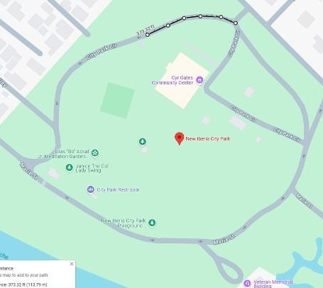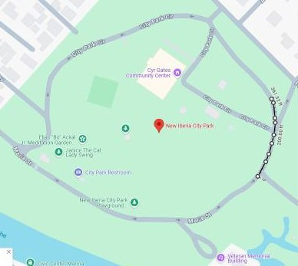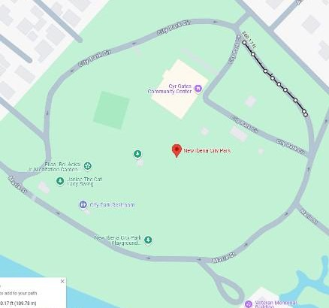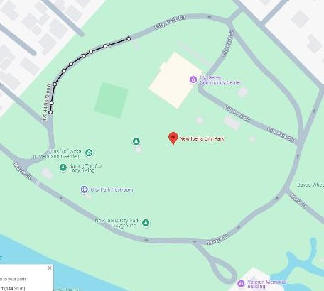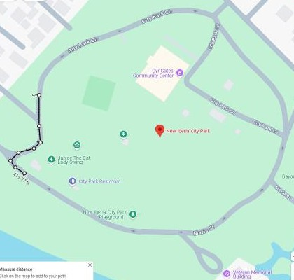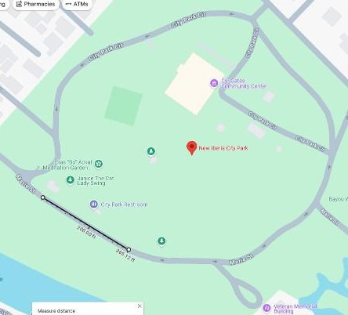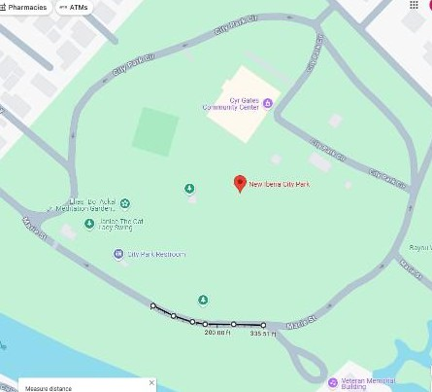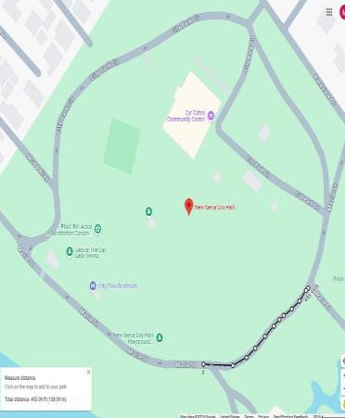

***Figure 1:*** Rider sequence and course map for the Acadiana 500 Tricycle Race

The project progressed through two distinct phases. Phase 1 comprised concept generation and analytical down-selection. Several frame geometries were tested in SolidWorks. The configuration combined a repurposed 1020-steel bicycle frame, fork, and handlebars with a custom rear axle assembly fabricated from AISI 4130 tubing and a heat-treated 4140 steels. Phase 2 translated the digital model into hardware. Components were CNC-machined to ±0.002 in tolerances, TIG-welded, and stress-relieved. Finite-element analysis (FEA) predicted a peak von Mises stress of 269 MPa under an 850 N rider load, corresponding to a factor-of-safety of 2.2. Dynamic analysis yielded a static tip-angle of 23°, and initial track trials confirmed a maximum achievable pedaling speed of 15 mph. Weekly design integrations verified with the head event chair and Acadiana 500 coordinator Hanna Pellerin to ensure continuous compliance and reduce unforeseen issues.

The completed tricycle weighed 35 lbs, passed inspection, and subsequently won first place in each individual heat of the 2025 Acadiana 500 relay race, validating the design’s methodology and proving that the low cost acquired parts, comprised of steel and chromoly frame, could outperform older winning iterations.

# Design Requirements

The design of the racing tricycle for the Acadiana 500 competition was formulated by a combination of strict dimensional rules, customer requirements, and practical resource constraints. The design phase served as the foundation for all future engineering activities, directing decisions on geometry, materials, and functional operations. This section outlines the rules imposed by the Acadiana 500 race specifications, defines the design’s expectations and performance goals, details the teams conceptual development process, and concludes with the rationale for selecting the final manufactured configuration.

## Dimensional Constraints and Race Rules

The Acadiana 500 competition imposed strict design constraints intended to ensure fairness, simplicity, and rider safety. All tricycles were required to be strictly foot-powered— prohibiting chains, gears, and motors. Instead, pedals had to be directly attached to the front wheel hub in a simplified front-wheel-drive configuration. This rule removed any mechanical advantage and placed added importance on crank arm geometry and ergonomics to maximize torque transfer from the rider to the ground.

Dimensional limits were also tightly defined. The tricycle could not exceed 20 inches in width, 24 inches in overall length, or 32 inches in height. Seat height was restricted to a maximum of 25 inches, including padding. The pedal tip was limited to a maximum of 12 inches from the front wheel center, enforcing a compact pedaling layout. The final design measured a rear axle track width of 19.5 inches and a wheelbase of 23.75 inches, fully contained within the allowable envelope. The seat pad height was 24 inches, remaining compliant while providing adequate rider posture for adults. Pneumatic tires were recommended for track traction and shock absorption. The team selected a 20-inch diameter front wheel paired with 10-inch rear wheels. All wheels used inflatable rubber tires to ensure smooth, consistent rolling contact. A coaster brake was integrated into the front hub to meet the race’s braking policy, which allowed foot-dragging or pedal-based systems only. The rest of the dimensional constraints compared to the final design the FPE team chose can be seen in the following table:

***Table 1:*** Dimensional Rule Compliance of Final Tricycle Design

|  |  |  |  |
| --- | --- | --- | --- |
| **#** | **Acadiana 500 Rule / Constraint** | **Dimensional Specification** (in) | **FPE Design** (in) |
| 1 | Seat-top height (ground → top, padded) | 22–24 or ≤ 25 (padded) | **23–24.2 (with pad)** |
| 2 | Highest point on tricycle | ≤ 32 | **31.5** |
| 3 | Handlebar & rear-axle width | ≤ 20 | **19.75** |
| 4 | Crank-arm radius | ≤ 4 | **4** |
| 5 | Outside pedal-to-pedal span | ≤ 24 | **17.5** |
| 6 | Front-wheel center → outer pedal tip | ≤ 12 | **8.75** |
| 7 | Max pedal envelope (height × width) | ≤ 6 × ≤ 6 | **4 × 5** |
| 8 | Rear-axle track / overall trike width | 17–20 | **19.7** |
| 9 | Wheelbase | ≤ 24 | **23.75** |
| 10 | Front-wheel diameter | ≤ 20 | **20** |

Beyond rule compliance, the tricycle had to withstand dynamic loads from sprinting, cornering, and rider transitions. The structure was designed for rider weights up to 250 lbs, necessitating a steel frame and robust component connections. No suspension system was permitted or required—vibration damping was achieved through the natural compliance of the steel frame and the pneumatic tires. Sharp edges and protrusions were eliminated to reduce injury risk, and steering response was carefully tuned for stability and maneuverability on the tight transition zones of the city park course.

### Design Objectives and Performance Goals

To ensure that the final product was not only compliant but competitive, the team defined a set of explicit design objectives. These included minimizing weight while maximizing structural strength, reducing rolling resistance, ensuring ergonomic comfort for all eight team members, and enabling rapid rider transitions.

Key goals included:

* + 1. Achieving high top speed via optimal wheel sizing and weight control
    2. Maximizing durability to prevent mid-race failures
    3. Ensuring safe, responsive steering and cornering under load
    4. Maintaining ease of assembly and repair
    5. Meeting all physical constraints without compromise

To connect these goals to measurable performance criteria, the team constructed a House of Quality (HoQ), mapping customer expectations to quantifiable engineering characteristics. These included total weight, frame yield strength, axle stress capacity, seat adjustability, and cost. The HoQ prioritized safety, acceleration, dimensional compliance, and comfort as top-level goals. Each requirement was associated with one or more engineering variables, and conflicts or synergies among them were identified through a triangular correlation roof in the matrix.

## House of Quality

As shown in Figure 2, the House of Quality displays all customer requirements as a function of engineering characteristics while gauging a value of the importance for each. The main purpose of the House of Quality is to coordinate hierarchy with respect to the most important and the least important customer requirements vs the engineering characteristics. This HoQ design tool helped the Fast Pedal Engineers in not only analyzing dimensional constraints quickly but gave an insight into which requirements were most important when considering the functionality of a design.

++

|  |  |  |
| --- | --- | --- |
| ◉ | Strong |  |
| ▣ | Medium |  |
| ▵ | Weak |  |

++

++

|  |  |  |
| --- | --- | --- |
| ▲ | Maximize |  |
| ▼ | Minimize |  |
| x | Target |  |

+

+ ++ ++

|  |  |  |  |
| --- | --- | --- | --- |
| **++** | Strong Positive | |  |
| **+** | Positive |  |  |
| **-** | Negative |  |  |
| **--** | Strong Negative | |  |

+ **+ +**

+ + --

+ ++

**+**

- + + ++

**Direction of Improvement** ▲ ▲

**Engineering Characteristics**

▲ ▼ ▼

▲ ▼ ▲ X X

**Customer Requirements**

**Importance**

Overall Width, Length, Height (in)

Total Weight (lb)

Seat Height Adjustability (in)

Frame Yield Strength (psi)

Axle Stress at Max Load (psi)

Factor of Safety (FoS)

Assembly Time (hrs)

Durability / Axle Stress at Max Load (psi)

Rolling Resistance (lbf)

Total Manufacturing Cost ($)

10 ensure rider safety under all conditions ▵

9 Allow stable and responsive steering and turning ▣ ▣ ▣ ▣

10 Penable constant rolling movement ▣

8 pneumatic tires for shock absorption ▣

2 modifed coaster brake system for free spin pedals ▣ ▵

10 Use direct pedal to front wheel drive

10 NO motors, NO gears, NO chains, NO mechanical advantage

10 Achieve high speed, acceleration, and efficiency ◉ ◉ ◉

9 Provide an ergonomic and comfortable seating arrangement ▵ ▵

10 Seat height must not exceed 25 inches (w/ padding) ▣ ▣

10 Maintain size dimensions: ≤20" wide, ≤24" long, ≤32" high ◉ ▣

10 Accommodate a variety of rider sizes and weights ◉ ▵

10 Minimize assembly time ◉ ▣

10 Maintain ≤12" from pedal to front wheel centerline ▣ ▵

10 Withstand race stresses without failure ◉ ◉ ▵

10 Minimize overall design weight for performance ▣ ▣ ▵

10 Minimal Cost ▵

1. user-friendly operation ▣ ▣ ▣
2. Meet all intended functionality and operational objectives ◉ ◉ ◉

◉ ◉ ▣ ▣

* + ▵

▵ ▣ ▣

◉ ◉ ◉

▵

◉ ◉

◉ ◉

▵ ◉

▵ ◉

▣ ▣ ▵

▣ ◉ ▣

* + ▵

▣ ▵

▣

▵ ◉ ▵

◉

* + - ▵

***Figure 2****:* House of Quality

The HoQ as seen on the last page in Figure 2, served as both a planning and evaluation tool frequently, ensuring no critical requirements were missed. A HoQ allows for the importance of each customer requirement to be ranked with importance, such as high speed, operational safety, and comfort. We can compare these customer requirements to the corresponding engineering characteristics. High-weighted metrics included frame yield strength, seat adjustability, and axle load capacity, while moderately weighted factors included manufacturing time and material cost.

The matrix revealed the tradeoffs between reducing weight and maintaining structural durability. It also highlighted the critical importance of maintaining compact dimensions without compromising performance. The team used the HoQ to narrow down feature combinations and guided all design iterations to align with the customer requirements. To supplement the HoQ, an evaluation matrix was created that scored each concept (0–10) across all performance and compliance criteria. This matrix validated that the final design chosen—using a steel frame, coaster brake, 20-inch front wheel, and banana seat—offered the most optimal balance of safety, speed, maneuverability, and compliance.

The Acadiana 500 Race imposes specific design requirements that shaped the tricycle’s design. The requirements and design specifications are attached in the Appendix. These requirements stem from both the competition’s official rules and general customer needs, or rider expectations, for safety and performance. Key design constraints included the following.

* **Foot-powered drive:** The tricycle must be strictly human-powered with no chains, gears, or motors permitted. Pedals must be directly attached to the front wheel hub, or the front- wheel drive, to provide propulsion. This direct-drive configuration simplifies the drivetrain but limits mechanical advantage, so the pedal/crank arm geometry had to be optimized within the allowed bounds (maximum 12-inch distance from pedal to wheel center).
* **Dimensions:** The tricycle must fit within certain dimensional limits to pass the compliance check. According to the race specifications, the overall width could not exceed ~20 inches, overall length ~24 inches, and overall height ~32 inches. Additionally, the seat height was required to be no more than 25 inches from the ground for a low center of gravity and rider stability. The chosen design was carefully scaled to meet these limits – the final wheelbase

(front axle to rear axle) is 23.75 inches, and the rear track width is 19.5 inches, keeping within the 24”×20” footprint. The seat pad height is 24 inches, complying with the 25” max rule while still providing a comfortable riding posture for adults. Figure 3 provides some of these critical dimensional limits and requirements:

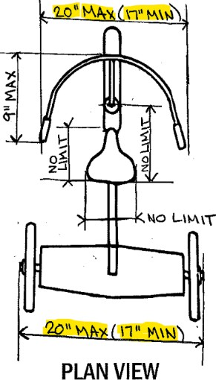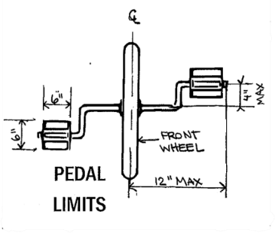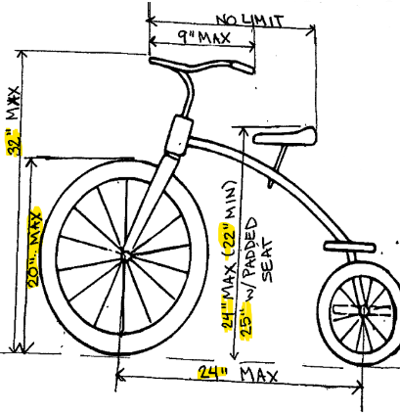

***Figure 3****:* Acadiana 500 Specific Dimensional Constraints

* **Wheels and Tires:** Pneumatic tires are an option (solid tires are not recommended) to ensure good traction and shock absorption on the track. The front wheel diameter is limited to 20 inches maximum for fairness and stability, and the design uses a 20-inch front wheel as allowed. Two smaller rear wheels, 10-inch diameter each, were selected for the back, which helps keep the weight low and meet the compact size requirements. All tires are inflatable rubber, providing constant rolling contact and a smooth ride on the park’s pavement. A coaster brake (pedal-actuated brake) is acceptable per rules and was integrated into the front wheel hub.
* **Safety and Durability:** The tricycle must be able to support an adult rider’s weight and withstand the dynamic forces during pedaling, turning, and rider swaps. Operational safety is a top priority – the frame and steering system should be robust enough to endure

sudden loads or bumps without failure. Additionally, edges and protrusions should be minimized for safety. The design needed to balance strength and weight: a lighter tricycle is faster and easier to handle, but it must not compromise on sturdiness. Because the race conditions involve multiple riders of varying sizes, the frame was designed for a broad range of rider weights (up to ~250 lbs). Durability in racing conditions, including sprinting and cornering, was ensured by using high-strength materials and a proven frame geometry to prevent any structural bending or cracking over the race distance.

* **Maneuverability & Stability:** Given the tight turns and transitions on the course, the tricycle required a tight turning radius and responsive steering. A traditional bicycle-style front fork and handlebar assembly was used to provide intuitive steering control. The rear wheel spacing (19.5-inches apart) gives a stable base to prevent tipping, and the low seat keeps the center of gravity low for improved handling. There is no articulated suspension; instead, the inherent flex of the frame and the pneumatic tires provide some compliance. The ease of use for the riders was considered – the steering handlebars are set at a comfortable height, and the seat is padded, accommodating riders of different heights with minimal adjustment.

## Concept Generation and Iteration

Three initial design concepts were developed in SolidWorks by team members Matthew, Andre, and Katie, see the Evaluation Matrix for more details below in Figure 4. Each concept featured different combinations of materials, wheel sizes, and frame geometries. One approach emphasized ultra-lightweight aluminum tubing but introduced concerns over weld fatigue and stress concentrations. Another used a conservative all-steel frame, resulting in a structurally robust but excessively heavy configuration. A third design reused salvaged components from donated bicycles, including a rigid steel frame, front fork, and handlebars—all verified to be AISI 1018 or 1020 steel.

|  |  |  |  |  |  |
| --- | --- | --- | --- | --- | --- |
| **Importance** | **Customer Requirements** |  |  |  |  |
| 10 | Ensure rider safety under all conditions | 9 | 7 | 9 | 9 |
| 9 | Stable and responsive steering | 9 | 7 | 6 | 10 |
| 10 | Allow constant movement | 10 | 9 | 9 | 9 |
| 8 | Pneumatic tires | 9 | 8 | 7 | 9 |
| 8 | Front Coaster (Free spin) | 8 | 3 | 7 | 9 |
| 10 | Front wheel pedal drive | 10 | 10 | 10 | 10 |
| 10 | No motors, chains, or gears | 10 | 10 | 10 | 10 |
| 10 | constant speed | 9 | 7 | 8 | 8 |
| 9 | Ergonomic seating | 7 | 9 | 9 | 9 |
| 10 | ≤20" wide, ≤24" long, ≤32" high | 8 | 7 | 7 | 10 |
| 10 | Seat height ≤ 25" (W/ Pad) | 9 | 8 | 7 | 10 |
| 10 | Support variety of rider weights & sizes | 8 | 6 | 8 | 9 |
| 8 | Assembly time | 8 | 9 | 7 | 7 |
| 10 | Stress withstanding capability | 9 | 6 | 9 | 9 |
| 10 | User friendly | 10 | 8 | 8 | 9 |
| 8 | Min design weight | 9 | 6 | 8 | 9 |
| 7 | Minimal cost | 5 | 7 | 7 | 8 |
| 10 | Meet intended functional and operational objectives | 9 | 7 | 8 | 10 |
| **Total** | | **1461** | **1251** | **1346** | **1529** |
| **Relative Total = Total / Number of Criteria** | | 0.81 | 0.70 | 0.75 | 0.85 |

***Figure 4:*** Evaluation Matrix of FPE Design’s - Concept Generation

To evaluate these concepts, the evaluation matrix which helped map critical design decisions—seat type, pedal mounting, axle support method, and wheel configuration—to viable options. This chart was cross-referenced with the HoQ and evaluation matrix to systematically eliminate weaker concepts and reinforce stronger alternatives. The final design used salvaged bike parts that were structurally strong and readily weldable, reducing manufacturing cost without compromising safety. These included the steel frame, front fork, and handlebar stem. This reuse strategy negated the need for external sponsorships and expedited the manufacturing phase.

## Key Design Features and Innovations

While most parameters were strictly regulated, the team found three areas where innovation could offer competitive advantage without violating constraints. First, a 7-inch TIG-welded stem extension improved ergonomic clearance, enabling taller riders to pedal with full range of motion. Second, the use of an 18-inch banana seat allowed riders to shift forward or rearward during pedaling, adjusting their center of gravity in real time and facilitating faster rider transitions. This seat type had no length restriction in the rules, and its profile reduced rider instability during acceleration. Third, the team maximized speed potential by selecting the largest allowable 20-inch front wheel, yielding the highest linear displacement per pedal stroke. Analytical comparisons indicated that a smaller 16-inch front wheel would have reduced top speed by approximately 20% due to lower gear ratio and shorter effective travel per rotation. While a smaller wheel might marginally improve acceleration at low speeds, this benefit was outweighed by the need for higher sustained velocity on straight sections of the course. Combined, these design choices led to a final configuration that was stable, responsive, and highly maneuverable, while maintaining full rule compliance. The design’s ability to accommodate different rider sizes, support loads up to 250 lbs, and transition quickly between riders gave it a distinct performance edge on race day.

To make sure that each requirement was systematically met, a House of Quality analysis was performed in the early design stage. This quality matrix mapped customer requirements (speed, safety, ease of use, etc.) to engineering characteristics (weight, dimensions, materials, etc.) and helped rank the importance of each. Critical customer needs such as operational safety, rolling performance, and maneuverability received the highest weighting. The House of Quality results guided the team to focus on features like a sturdy steel frame, reliable steering linkage, and low- friction wheels. In addition, an evaluation matrix was utilized to compare different conceptual solutions against the list of requirements. As shown in Figure 1, each proposed design iteration was scored from 0 to 10 based on how well it satisfied each criterion. This quantitative approach ensured that the final chosen design would represent the best trade-offs among all requirements. In summary, by adhering to the dimensional constraints and incorporating the above features, the design meets 100% of the Acadiana 500 Tricycle Race specifications and addresses the primary customer needs for a safe, functional, and competitive racing tricycle.

# Technical Approach

The final tricycle configuration was developed through iterative CAD modeling, concept evaluation, and targeted material selection, all while adhering strictly to the Acadiana 500 design rules. The figure below shows the final CAD model of the tricycle design with key dimensions annotated. This model was developed in SolidWorks and reflects the final configuration built for the race. The drawing provides multiple views, including top, side, front, and isometric perspectives, and highlights the critical dimensions such as wheelbase, seat height, handlebar width, and overall height. This section outlines the system-level design rationale, performance constraints, and decisions that shaped the final product.

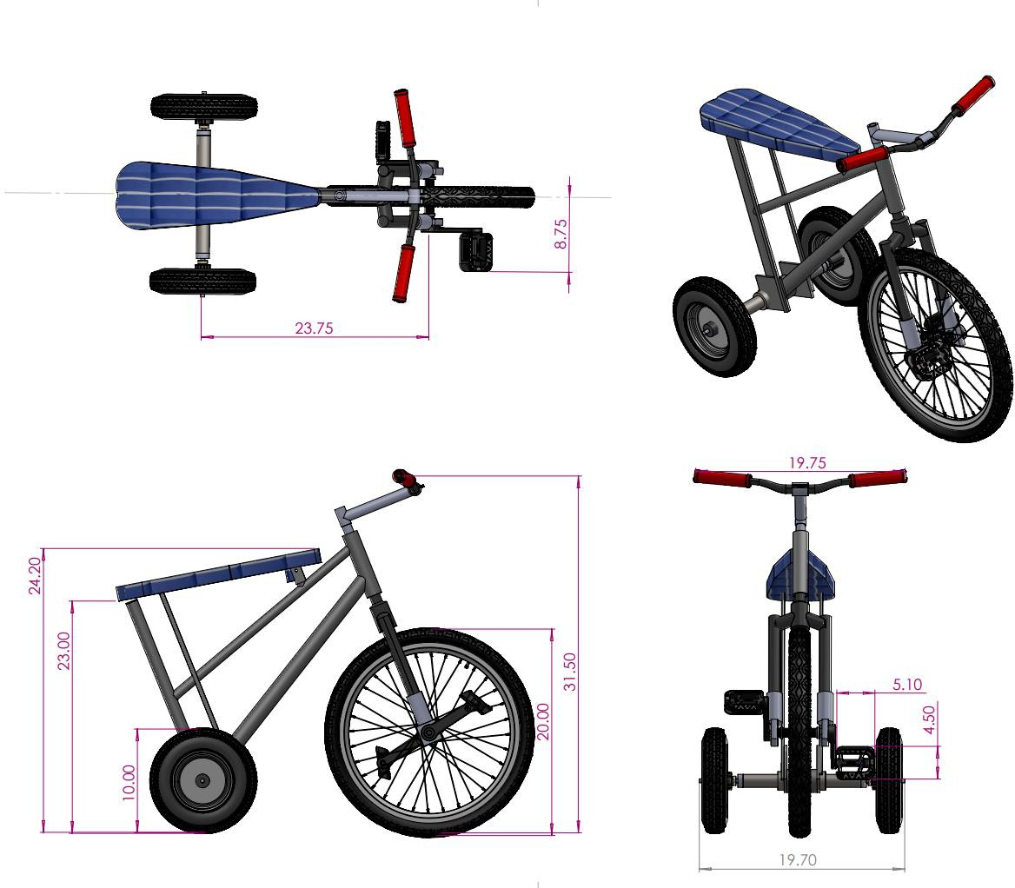

***Figure 5***: Final Tricycle Design Drawing

## Functional Requirements

The tricycle was required to be fully human-powered with no chains, gears, or motors, and compliant with all dimensional constraints: a maximum 25-inch seat height, 20-inch maximum track width, and a 12-inch limit from front wheel center to pedal tip. Pedals were required to be directly connected to the front wheel hub, eliminating mechanical advantage and necessitating careful optimization of rider leverage and cadence.

Each team member developed a unique concept in SolidWorks, all compliant with rule specifications. Concepts varied in frame geometry, wheel sizing, and component reuse. The development of the final tricycle design progressed through a series of iterative CAD models, as shown in Figures 6–9. Design Iteration 1 focused on a basic direct-drive configuration using simplified geometry, allowing the team to explore fundamental packaging and dimensional compliance. Design Iteration 2 introduced refinements in frame geometry, adjusting the seat position and rear wheel spacing to improve rider ergonomics and weight distribution. Design Iteration 3 incorporated a more robust triangular frame, a revised front fork angle, and upgraded wheels, significantly improving stability and manufacturability. Finally, the actual tricycle design represents the culmination of the iterative process, integrating performance-optimized components such as the extended quill stem, reinforced seat support, and optimized rear axle assembly. This iterative approach ensured that each design evolution addressed both functional requirements and manufacturing feasibility, ultimately delivering a competitive and reliable race vehicle. Using an evaluation matrix weighted by performance, manufacturability, and safety, the selected concept (Iteration 4) received the highest composite score of 0.85, outperforming alternatives (0.81, 0.74,

and 0.69).

The final design featured a 20-inch pneumatic front wheel with an integrated coaster brake and 4-inch crank arms. The frame was constructed from a salvaged mountain bike frame made of 1020 steel, chosen for its high strength and weldability. The rider was positioned roughly two- thirds of the distance from the front wheel to the rear axle, yielding balanced traction and improving handling. Steering was achieved through a reused fork, modified to accept the front hub. The original headset and quill stem were retained to maintain reliable steering geometry. A

coaster brake mechanism permitted backpedaling and free-spinning, allowing safer transitions by reducing the risk of over-rotation injuries when the rider disengages.

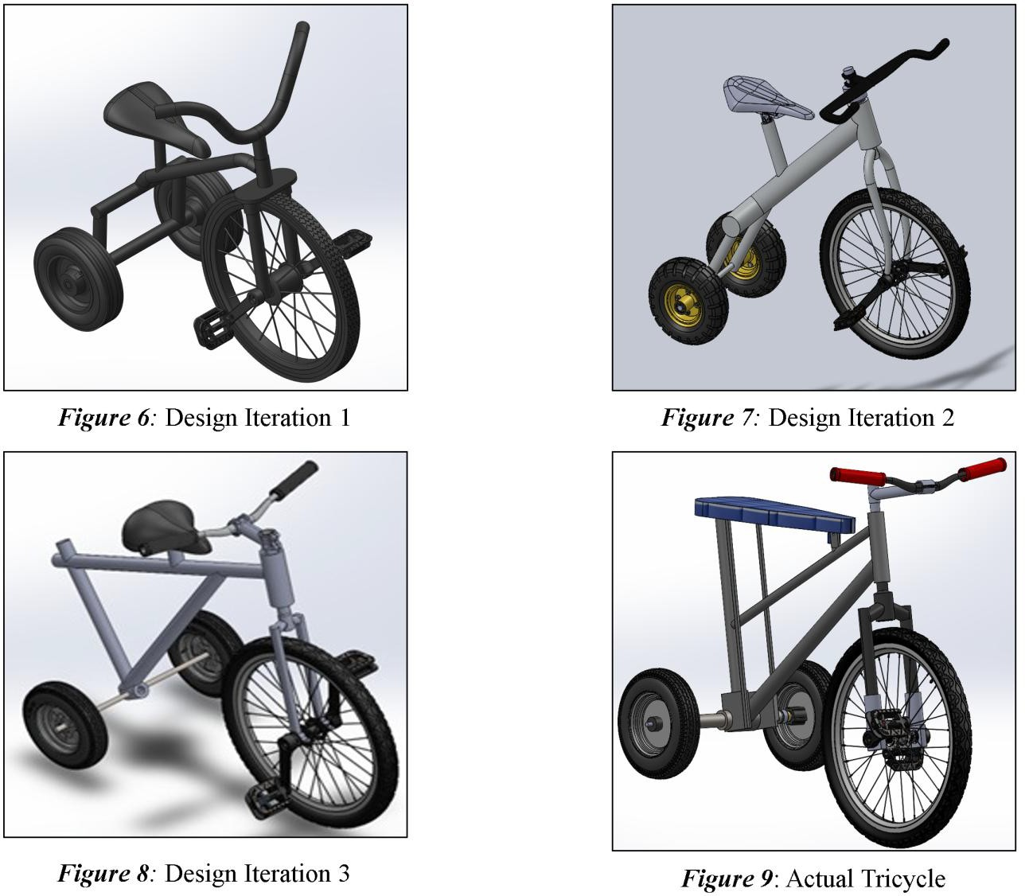

The selected configuration met all performance and rule-based requirements and laid the groundwork for subsystem design and testing, discussed in the following sections. In the final configuration, the tricycle’s layout consists of a single driven front wheel with pedals and two rear wheels on a common axle. A conventional bicycle-style front fork and handlebar are used for steering. The rider sits just behind the front wheel, almost centered between the front and rear axles, which distributes weight evenly and improves traction on the front drive wheel. This layout addresses the functional requirements as follows:

* **Propulsion**: Pedaling is accomplished via crank arms attached to the front wheel hub, directly driving the wheel. This satisfies the no-chain rule and creates a simple, low- maintenance drivetrain. The crank arm length (pedal radius) is 4.0 inches, which is sufficient to provide leverage while remaining well under the 12″ maximum radius allowed. This length was chosen to balance cadence and torque – it allows riders to accelerate from rest and climb the small inclines of the track without excessive leg strain yet permits a fast-pedaling cadence for speed on straightaways.
* **Steering**: The handlebars and front fork assembly allow the rider to steer the front wheel. Because the design reuses an existing bicycle fork and handlebar, the steering geometry (head tube angle, trail) is inherently stable and familiar. This provides responsive handling so the rider can navigate curves and avoid obstacles. The fork’s range of motion covers the needed turning radius for the track layout. The handlebar width is kept moderate (approximately 18″ wide) so that the overall width stays within 20″ and the rider has good leverage to turn the wheel. A slight modification was made to the fork’s ends to accommodate the new front wheel hub (as described later in the Fork Attachment), ensuring the steering axis remains correct.
* **Support and Stability:** The frame forms a robust backbone connecting the front steering assembly to the rear axle. By using a metal frame (steel), the tricycle can safely support the loads. The reused bicycle frame provided a proven ergonomic shape – it includes a head tube for the fork, a down-tube, and a seat tube. This frame was originally part of a standard road bicycle; the rear triangle of the bike was removed, and the frame was adapted to hold the new rear axle. The resulting structure is a Tadpole tricycle layout (one wheel front, two rear) using the front half of a bicycle. Stability is achieved through the wide rear stance and low center of gravity. During rider transitions (when one rider hops off and another hops on during the relay race), the tricycle’s stable three-point support prevents tipping. The seat is positioned roughly 22 inches behind the front axle (horizontal distance), and with a rider seated, the combined center of gravity is approximately 23 inches off the ground – low enough to reduce the risk of rollover in sharp turns. The Appendix shows the

rear seat support drawing created, which provides structural reinforcement beneath the banana seat to accommodate different rider weights.

* **Free spin (back pedal):** A coaster brake is integrated in the front wheel hub, allowing the rider to free spin by back-pedaling. This mechanism was chosen to improve safety and prevent riders from getting their legs injuries if their feet are not able to keep up with the pedal speed. – since the race emphasizes safety, having a this is crucial, and a coaster meets the “coasters acceptable” rules. Overall, the chosen design is a direct-drive adult tricycle that meets all functional objectives: the rider’s pedaling input is effectively translated to forward motion; the steering and brakes give full control; and the frame/axle system supports the loads with a generous safety margin. The next sections detail the specific design of each major subsystem, and the engineering analyses performed to validate the design.

## Subsystem Design and Key Components

To facilitate both the design process and manufacturing, the tricycle was divided into several key subsystems or assemblies: the frame, the front wheel drive and steering assembly, and the rear axle assembly. An exploded view CAD model of the tricycle and its subsystems can be seen below:

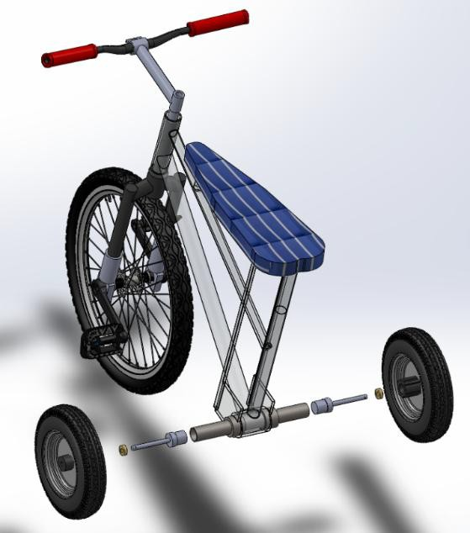

***Figure 10****:* Final Design Exploded View

Each subsystem was designed to fulfill certain functions and to interface with the others smoothly. The final CAD model provided dimensional details for all custom parts, which were then fabricated according to engineering drawings. The following table and subsections describe each subsystem, including how critical components were dimensioned and how they satisfy the customer requirements:

* + 1. **Frame (main body):** The frame serves as the main structural element of the tricycle. For this design, an existing steel bicycle frame (made of welded 1020 steel tubing) was repurposed. This frame was chosen because it already featured a strong triangular geometry and included the head tube, down tube, top tube, and seat tube needed for mounting the fork and seat. To convert it for tricycle use, the rear portion of the bicycle frame was removed just behind the bottom bracket. This left a sturdy front half to which the new rear axle could be attached. The bottom bracket shell (the round housing where bicycle crank bearings normally sit) became a convenient location to install the rear axle assembly. By reusing the frame, the design leveraged the high strength-to-weight ratio of the steel bike frame and its ready-made ergonomic shape.

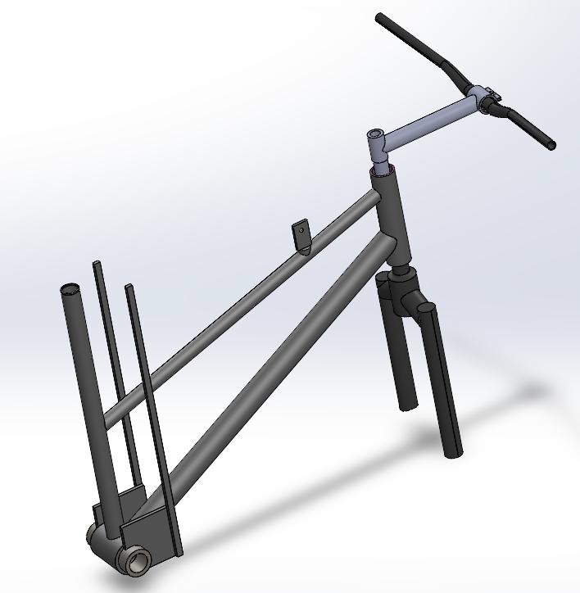

***Figure 11*:** SolidWorks Model of Frame

The frame’s geometry naturally kept the rider’s weight low and between the wheels. It was verified that the frame’s dimensions fit within the race’s limits: after modification, the frame length from the front fork to the end of the seat tube was about 24″, and the height to the handlebars ~30″, satisfying the 24″ length and 32″ height constraints. The frame also provided a seat tube to mount the saddle; the seat height is adjustable within a small range (around 22–24″) to accommodate different riders while staying under the max height, as seen in Figure 9. No major changes to the frame’s front structure were needed, preserving its integrity. Only minor grinding and welding were performed at the rear to integrate the axle. The result is a very rigid base – steel’s yield strength (~50 ksi) and toughness ensure the frame can handle rough use. By using the existing head tube and fork interface, proper alignment of the steering system was maintained with minimal fabrication.

* + 1. **Front Wheel Drive and Steering Assembly:** The front assembly comprises the 20″ front wheel with pedal cranks, the fork, the handlebars (with stem), and the head tube interface. This subsystem is effectively a modified bicycle front end that provides both drive and steering:
       1. **Front Wheel & Pedals***:* The front wheel is a 20-inch diameter pneumatic tire mounted on a hub that has integrated pedal cranks (a “front pedal drive” hub). This wheel was sourced from a commercially available adult tricycle or a children’s bike that uses direct front-wheel pedaling. It includes a built-in coaster brake mechanism. The hub’s design allows crank arms to be attached on either side, to which standard bicycle pedals are fitted. The crank arms used are steel, 8 inches long end-to-end (giving the 4-inch pedal radius). The pedal travel is thus comfortable and not overly large for the riders. Using this off-the-shelf front wheel assembly significantly simplified the design – it came with internal bearings and the brake, reducing the number of custom parts needed.

The attachment of the front wheel to the fork required a custom solution: unlike a normal bike wheel which has a threaded axle that slides into fork dropouts, the pedal hub is a larger assembly not directly compatible with the old fork dropouts. To solve

this, a fork attachment bracket (or bearing holder) was designed. This custom fork adapter, shown in the Appendix with specific measurements, bolts or welds to the fork’s dropout ends and captures the front wheel’s axle securely. Essentially, it acts as a clamp around the hub’s ends, maintaining the wheel in place while allowing it to spin freely. The adapter was machined from steel and included provisions for the coaster brake’s reaction arm to be anchored to the fork so that braking torque is transferred to the frame. This fork attachment aligns the wheel centrally in the fork and ensures the wheel’s axle is at the correct offset in the dropouts. Tolerances of

±0.005″ were held on the holes and mating surfaces to ensure a snug fit with no slop, which is important for steering precision.

* + - 1. **Fork and Steering Stem:** The front fork is the original bicycle fork that came with the reused frame. It is a tubular steel fork (also 1020 steel) with an integrated steering column (quill) that fits into the frame’s head tube. The fork was modified at the dropouts to interface with the new front wheel as described. Otherwise, its geometry remained the same. The fork’s sturdiness was assessed: it is designed for a larger bicycle wheel originally, so a 20″ wheel is well within its capacity. The fork is attached to the frame via a standard headset with bearings, allowing smooth rotation for steering. The handlebars are attached using the original quill stem – a steel stem that clamps onto the fork’s steerer tube and holds the handlebars.

The stem position was adjusted for rider comfort, and a set of rubber grips was added to the handlebars for better control. Because the reused fork and stem were in good condition, they required only minimal refurbishment (cleaning and new grease in bearings). One special note is the steering stop: to prevent the fork from over- rotating and the pedals hitting the rider’s legs sharply during extreme turns, the design relies on the natural limit of the fork against the frame. The handlebar will contact the frame at a certain angle, acting as a stop. This angle is beyond what is needed in normal turning, so it doesn’t impede maneuverability but adds a safety factor. The Appendix includes the SolidWorks drawing of the custom quill stem, designed to extend the handlebar height for ergonomic rider positioning.

* + - 1. **Seat:** While part of the frame, it’s worth noting the seat in context of the front assembly – the seat is directly above the pedals and slightly behind, which means rider weight presses down between the wheels. A new padded seat was installed on the seat post for comfort (padding is explicitly allowed by rule). The seat post is clamped in the frame’s seat tube and can be adjusted. The final seat height used is 24″ for the tallest rider. The seat and handlebar positions together ensure an ergonomic posture so that riders can pedal efficiently without their knees hitting the handlebars (the original bike’s geometry and the curved handlebar design provided ample knee clearance). This ergonomic was checked with riders of different leg lengths during assembly.
    1. **Rear Axle and Wheel Assembly:** The rear of the tricycle includes two wheels mounted on a common axle that is affixed to the frame. This subsystem was entirely custom-built since the original bicycle frame was single-track and had no provision for two rear wheels. The rear assembly consists of a central axle tube, two center bushings that mount this tube to the frame, an internal axle rod with stepped ends (also called rear wheel bushings or stubs) that holds the wheels, and some spacer components for proper wheel positioning. All these components were machined to precise dimensions as per the design drawings:
       1. **Axle Support Tube***:* A length of AISI 4130 steel tubing is used as the main rear axle housing. This tube is 11.3 inches long, chosen to match the required rear track width while fitting through the frame’s bottom bracket. The tube’s outer diameter is about

1.25 inches, with a wall thickness such that its inner diameter is ~1.06 inches. This sturdy chrome-moly tube was donated by the machine shop; 4130 steel is known for its high strength (tensile ~100,000 psi) and good toughness, making it ideal for a load- bearing axle. The tube spans the width of the tricycle and passes through the bottom bracket shell of the frame (the round opening at the base of the seat tube), as seen in Figure 10. To secure this tube in the frame, two frame bushings were made. These rear axle center bushings are like thick washers or sleeves that fill the gap between the

1.25″ axle tube and the larger diameter of the bottom bracket shell. Each bushing is machined from AISI 1018 steel to dimensions of 1.80″ outer diameter (to press fit

tightly into the bottom bracket) and 1.25″ inner diameter (to snugly hold the axle tube). The bushings are 0.25″ thick.

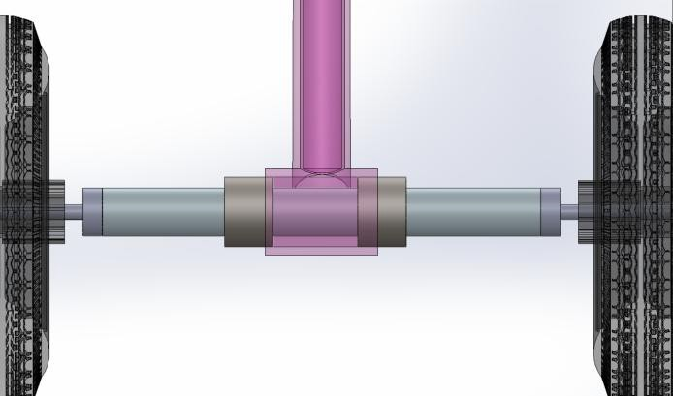

***Figure 12*:** Rear Axle Sub Assembly

During assembly, one bushing is inserted on each side of the bottom bracket and the axle tube runs through them, centered in the frame. The bushings were designed for an interference fit: their OD was made a few thousandths of an inch larger than the frame hole, and they were pressed in, creating a very solid junction. The 1018 mild steel material was chosen for these bushings because it machines easily to a fine tolerance and is sufficiently strong to carry the shear load. Additionally, 1018 welds well – if needed, small tack welds can be applied to lock the bushings in place in the frame (weld integration was planned to ensure they do not loosen over time). Once installed, the 4130-axle tube is rigidly held coaxial with the frame and acts like a cross- member connecting the two sides of the frame. This construction essentially turns the bicycle frame into a tricycle frame with solid rear axle support.

* + - 1. **Internal Axle Rod and Wheel Bushings:** Inside the 4130-axle tube goes the actual rear axle rod that the wheels attach to. This part was one of the more complex custom pieces. It was machined from a piece of high-strength steel (initially planned as 4140 steel, heat-treated) to have multiple diameters. The design is such that the rod fits through the 4130 tube and extends out of both ends to provide stub axles for the rear wheels. The rod’s mid-section diameter is slightly less than the tube’s inner diameter, to allow it to slide in freely. At each end, the rod steps down to a smaller diameter to fit the bearings or hubs of the rear wheels. The rear wheels that were obtained have

bearings sized for a 3/8-inch axle (approximately 0.375″). Thus, the ends of the rod were turned to about 0.385″ diameter to serve as axles for the wheels (this small oversize ensures a precise fit in the bearing with slight clearance). Shoulders were machined where the diameter changes – these shoulders seat against the tube ends or bushings and take the lateral loads.

To simplify the design understanding, this “rear axle tire bushing” piece has three sections: a middle section that fills the inside of the axle tube and two 3/8″ diameter outer sections that stick out for the wheels. The rod was made from 4140 steel for its superior strength (yield ~69,500 psi) and it was used in a hardened state to resist wear and bending. 4140 is more difficult to machine, but careful CNC turning yielded the needed accuracy. The part was then heat-treated (quenched and tempered) to ensure it can handle repeated shock loads without deforming. After fabrication, this internal axle rod is inserted through the hollow axle tube. It is positioned so that equal lengths protrude on each side for the wheels. Small retaining pins or collars were used to lock this rod axially: once centered, a cross-hole was drilled and a steel pin inserted through both the outer tube and the rod, effectively keying them together. This prevents the rod from sliding or rotating independently (in this design, the rear wheels and rod rotate together as one unit when the trike moves, and the outer tube is stationary with respect to the frame). Alternatively, set screws or welds can secure it – the method chosen was a press-fit pin so it remains serviceable.

* + - 1. **Rear Wheels and Spacers***:* Two 10-inch diameter wheels are mounted, one on each end of the axle rod. These wheels have hubs with internal ball bearings (for low friction rolling). The 3/8″ stub axles on the rod go through the wheel bearings. To hold each wheel in place on the axle, a small brass spacer and a nut are used on the outside. The tire bushing was machined for precise fit between the rear axle and wheel bearings to minimize rotational friction. The precise drawing with dimensions can be seen in the Appendix. The brass spacers (made from C360 brass alloy) are simple washer- like rings (1.25″ OD, 0.375″ ID, 0.25″ thick) that slide over the axle ends between the wheel hub and the retaining nut. These spacers serve two purposes: they take up any excess axle length to eliminate side-to-side wheel play, and brass provides a smooth

bearing surface if the wheel hub contacts it during rotation. Brass was selected for its good wear characteristics and ease of machining; two spacers were made, one for each wheel.

Finally, a threaded nut (with lock washer for safety) is fastened onto the threaded end of each axle rod stub (the tips of the 4140 rod were threaded during machining) to clamp the wheel and spacer against the shoulder of the rod. This way, the wheels are securely attached yet can spin freely on the fixed axle rod. When assembled, the rear wheels are spaced 19.5″ apart (center to center), matching the design width. The axle, being one piece, causes both rear wheels to rotate together. While this means there is no differential action in turns, the relatively small wheel size and track width make it manageable – the inside wheel can skid slightly on tight turns without much issue, and in practice the rubber tires have some give. This simple solid axle approach was deemed acceptable for the race conditions and avoids the complexity of freewheeling hubs on the rear (since propulsion is only through the front wheel, having freely spinning rear wheels was not necessary).

With the above configuration, the rear axle subsystem provides a strong and secure mounting for the two rear wheels. All dimensions were carefully controlled in manufacturing: for example, the center bushings’ OD (1.80″) was held to a few thousandths tolerance for proper press fit; the axle rod’s diameters (especially the 0.385″ for wheel interface) were turned within ±0.001″ to match the bearing IDs; and the alignment of cross-holes and threads were verified to ensure the assembly comes together without binding. The mechanical evaluation of the rear axle showed it to be very robust – the choice of 4130 and 4140 steels means the axle can handle the bending and shear loads with large safety factors. The assembly effectively ties the two sides of the frame together, increasing overall rigidity of the tricycle. This helps during pedaling (the frame will not flex or twist significantly, so pedaling energy isn’t wasted) and when hitting bumps. In summary, the rear axle and wheel subsystem met the design requirements by delivering a stable rear support, keeping the tricycle upright and balanced, while using durable materials that can last through the rigors of the race.

## Material Selection

Material selection was critical to achieving the design's strength, manufacturability, and weight goals. Table 1 below summarizes each material’s key mechanical properties and application rationale:

***Table 2:*** Structural Material Comparison

|  |  |  |  |  |  |  |
| --- | --- | --- | --- | --- | --- | --- |
| **Component** | **Material** | **Yield Strength (psi)** | **Density (lb/in³)** | **Machinability (%)** | **Weldability (%)** | **Source** |
| Frame, Fork, Stem, Handlebars | 1018/1020  Steel | 53700 | 0.284 | 60 | 85 | Salvaged |
| Front Clamp Sleeves (Fork Attach) | 1018 Steel | 53700 | 0.284 | 60 | 85 | Machined |
| Stem Extension | 1018 Steel | 53700 | 0.284 | 60 | 85 | Machined |
| T-Piece (Seat Insert) | 6061 Al | 40000 | 0.098 | 50 | 35 | Machined |
| Rear Axle Tube | 4130 Steel | 97000 | 0.283 | 35 | 60 | Machined |
| Rear Axle Stub Rod | 4140 Steel (HT) | 69500 | 0.284 | 40 | 40 | Machined |
| Bushings | 1018 Steel | 53700 | 0.284 | 60 | 85 | Machined |
| Brass Spacers | C360  Brass | 49000 | 0.307 | 80 | 20 | Machined |
| Side Seat Supports | Steel | 53700 | 0.284 | 60 | 85 | Machined |

## Proof-of-Concept and Hardware Validation

Early in manufacturing, proof-of-concept testing was conducted through SolidWorks. The axle housing was test-fitted into the bottom bracket to verify press-fit tolerances before heat treating and welding. The full assembly was fit with a rider to confirm pedal clearance, knee

clearance on turns, and ergonomics for best transitions. These tests prevented issues and provided confidence that all components fabricated and assembled as designed to high integrity.

## Testing and Simulation Results

To verify structural integrity, a static Finite Element Analysis (FEA) was conducted in SolidWorks. A static load of 850 N was applied at the seat post (representing a max rider of 190 lb plus dynamic buffer), with secondary pedal loads of 450 N and seat reaction forces of 150 N. The frame was constrained at the fork and axle mount.

***Table 3:*** FEA Setup of Input

|  |  |  |  |  |  |  |  |
| --- | --- | --- | --- | --- | --- | --- | --- |
| **FEA Case** | **Part Analyzed** | **Load** | **Fixed Conditions** | **Material** | **Max V.M.**  **(psi)** | **Yield Strength (psi)** | **FoS Calculation** |
| Axle Shear/ Bending | Rear Axle | 170 lbf midpoint | Bushings, force at center | 4140  Steel | 39700 | 69000 | FoS = 69000/39700  ≈ 1.74 |
| Frame Compression | Down Tube | Rider seated | Headset & axle base | 1020  Steel | 16200 | 51000 | FoS = 51000/16200  ≈ 3.15 |
| Seat Post Deflection | Seat Rail | 85 lbf end load | Support base | 1018  Steel | 3930 | 53000 | FoS = 53000/3930  ≈ 13.50 |
| Torsional Flex | Rear Axle to Frame | Turning torque | Rear axle ends, torque at front | 4130  Steel | 21900 | 97000 | FoS = 97000/21900  ≈ 4.43 |

The finite element analysis (FEA) performed on the tricycle frame was designed to assess the structural performance of its key components under realistic loading conditions. The objective was to determine whether the frame could safely endure the stresses it would encounter during both training use and more demanding scenarios like the race, which would ensure its overall safety and long-term durability. The study examined four critical loading cases, each focusing on a distinct area of the frame: the rear axle subjected to shear and bending forces, the downtube under compression from the rider’s weight, the seat rail under an end load, and the rear axle to frame connection experiencing torsional flex. For each scenario, the components were modeled with appropriate boundary conditions and material properties. The simulations focused on

identifying the maximum von Mises stress and comparing it against the material’s yield limit to calculate the factor of safety (FoS).

The findings were encouraging. The most critical case simulated yielded a factor of safety of approximately 1.74. While this was the lowest margin observed, it still indicated sufficient strength under static conditions. In contrast, the seat rail exhibited a notably high FoS of about 13.5, reflecting a conservative design and very low stress levels under its applied load. Both the downtube and the rear axle to frame connection showed solid safety margins as well, with factors of safety around 3.15 and 4.43, respectively. Taken together, these results suggest that the frame is well-engineered to withstand the expected forces without approaching material failure.

The simulation results can be seen in the figure below. The highest recorded von Mises stress was at 279.5 MPa in the seat-tube junction. Given the 1018 steel’s yield strength of 620 MPa, this resulted in a factor of safety of 2.2, indicating that the junction could sustain more than twice the applied stress before yielding. Although the analysis did not incorporate dynamic or time-dependent loads, which are common in real-world riding, the conservative approach used here still offers strong assurance of the design’s durability under both racing and everyday conditions.

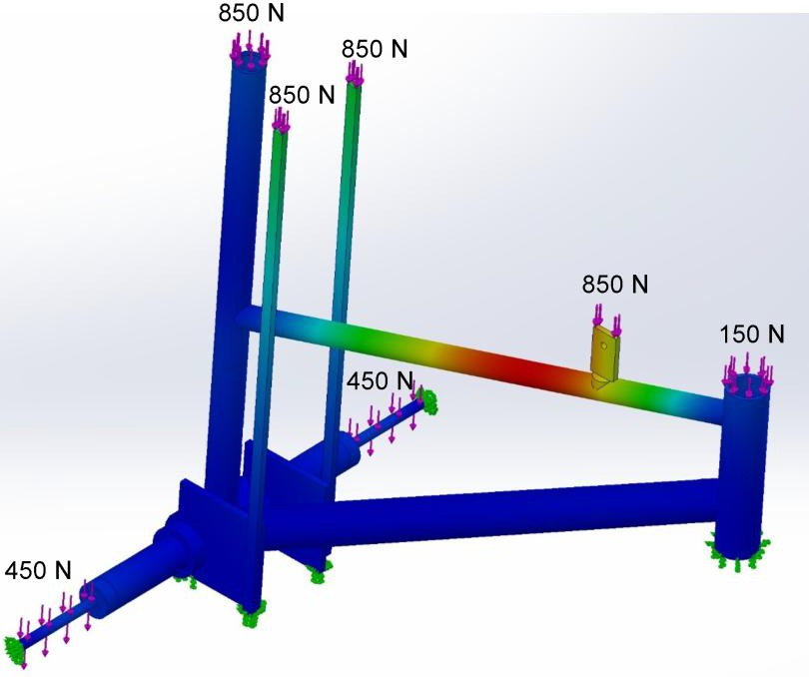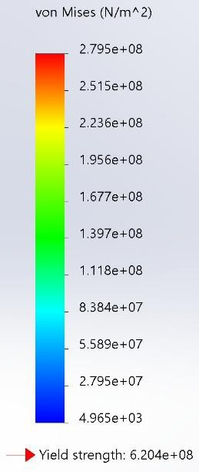

***Figure 13:*** FEA Simulation Results from Tricycle Frame

The stress distribution plot generated by the simulation offered additional insight, visually highlighting the areas of concern. The highest stress concentrations were localized near the seat- tube junction, shown in red, while other regions such as the frame base and side members exhibited much lower stress levels, represented by blue and green zones. The applied loads, ranging from 150 N to 850 N, realistically represented riding conditions, capturing the interaction between the rider’s weight, road forces, and the frame’s structural response. Ultimately, the FEA confirmed that critical regions, particularly weld zones and geometric transitions, remained safely below stress thresholds where failures typically originate. This validation is significant, as it indicates that the current design can reliably withstand expected loads without requiring post-simulation modifications. As a result, the tricycle frame was deemed ready for use as designed, providing confidence in both its safety and performance

***Table 4:*** Material Selection Yield Strength and Properties

|  |  |  |
| --- | --- | --- |
| **Property** | **Value** | **Units** |
| Rear Axle Shear Stress | 903 | psi |
| Rear Axle Bending Stress | 39700 | psi |
| von Mises Stress (Axle) | 39700 | psi |
| Yield Strength (4140, HT) | 69000 | psi |
| Axle FoS | 1.7 | - |
| Seat Deflection | 0.062 | in |
| Max von Mises Stress (FEA) | 279500000 | N/m² |
| Frame Yield Strength (4130 Steel) | 620400000 | N/m² |
| Frame FoS | 2.22 | - |

# Project Timeline

The design and manufacturing of the tricycle was executed over two academic semesters, with clear milestones ensuring the project stayed on schedule for the April race. A Gantt chart was used throughout the project duration to plan and track progress made for the project. A more detailed explanation of the design and manufacturing stages of the project are presented next:

* **Phase 1 – Conceptual Design (Fall 2024):** This phase encompassed initial research, brainstorming, and design selection. Weeks 1–3 were spent meeting with the event coordinator to fully understand rules and gather prior race insights. By Week 4, the team completed the House of Quality and established design requirements. Weeks 5–8 involved concept generation (sketches and SolidWorks models of three different tricycle concepts). In Week 9, the evaluation matrix was applied in choosing the final design. Weeks 10–12 focused on detailed design of the chosen concept – creating a 3-D CAD model of the frame and subsystems, and performing preliminary calculations. By Week 13, a finite element analysis was run on the proposed frame to verify its viability. The Fall 2024 Final Report (design proposal) was submitted in Week 15, documenting the selected design, analysis results, and plans for manufacturing in the next semester. This phase concluded with a design that was approved for fabrication.
* **Phase 2 – Manufacturing & Assembly (Spring 2025):** With design in hand, Phase 2 encompassed the building process of the tricycle. In weeks 1–2, the team sourced and ordered all necessary parts and materials. This included purchasing a 20-inch front wheel with pedals, two 10-inch rear wheels, bearings, a new seat, and small hardware like bolts and spacers. Concurrently, meetings were held with Mr. Jeff, the machine shop lab instructor, to review the drawings and machining plan. By Week 3, all off-the- shelf parts were either delivered or enroute, and the team verified each against the design (for example, confirming the front wheel’s pedal hub dimensions, the rear wheels’ bearing sizes, etc.). In weeks 4–6, machining of custom components took place. This was a critical path: the axle parts and adapters were fabricated in the lab during this period. The team members coordinated time in the shop, working under

supervision in scheduled sessions. Week 6 also saw the modification of the bicycle frame where the rear triangle was removed. By the end of week 7, the machining was completed successfully.

The project timeline followed its plan, with only minor adjustments (for example, machining took a bit longer than initially blocked, but slack was built in). The Gantt chart used proved helpful in visualizing the schedule; it clearly indicated deadlines such as “complete machining by spring break” and “testing completed two weeks before race”. The disciplined approach to the timeline ensured there was no last-minute rush or panic. Having a completed tricycle several weeks before the race not only is a relief for compliance but also provides an opportunity for the riders to practice – an often overlooked but crucial aspect for race success. See appendix for comprehensive Gantt chart.

# Expense Report

The project was executed on a modest budget, thanks largely to parts reused and sponsorship. The table below outlines the budget vs. actual costs for major items and how resources were obtained.

***Table 5:*** Expense Report

|  |  |  |  |  |  |  |  |
| --- | --- | --- | --- | --- | --- | --- | --- |
| **Part** | **Qty** | **Material** | **Source** | **Total ($)** | **Weight (lbs)** | **Machining (hr)** | **Welding (hr)** |
| Frame, Stem, Handlebar, Fork | 1 | 4130 Steel | Salvaged | 0 | 9.5 | 0 | 0 |
| Front Assembly | 1 | Steel /  Aluminum | Razer.com | 34.78 | 12.1 | 0 | 0 |
| Rear Wheels  (10") | 2 | Plastic/Rubber | E-Sport | 0 | 5.4 | 0 | 0 |
| Pedals | 2 | Plastic/Steel | Amazon | 28 | 0.66 | 0 | 0 |
| Banana Seat | 1 | Vinyl/Foam | Amazon | 45 | 2.2 | 0 | 0 |
| Stem Extension | 1 | 1018 Steel | Mr. Jeff | 0 | 4.7 | 2 | 0.5 |
| T-Piece (Seat) | 1 | Al 6061 | Mr. Jeff | 0 | 0.55 | 1.5 | 0 |
| Handlebar Grips | 1 | Rubber | Amazon | 6.98 | 0.50 | 0 | 0 |
| Side Seat Supports | 2 | Steel | Seat Purchase | 0 | 2.5 | 0.5 | 0.5 |
| Bushings/Spacers | 2 | Brass | Mr. Jeff | 0 | 0.41 | 1.5 | 0 |
| **TOTAL** | **14** |  |  | **114.76** | **39.1** | **5.5** | **1** |

Initially, the team budgeted approximately $300 for parts and materials (excluding the race fee). However, due to resourcefulness and support, the actual cost incurred was only about $200. The breakdown is as follows:

* The **race registration fee of $250** was fully covered by a sponsor (Raising Cane’s Chicken Fingers). The team successfully obtained this sponsorship early in the project by presenting the design proposal to the company. In return, the team will display the sponsor’s logo on the tricycle and possibly at the event. This was a significant budget relief, effectively providing free entry to the competition.
* The **front wheel assembly** was an essential purchase; at $35 it was reasonably priced as it included the hub, cranks, and even a pair of pedals. This was ordered online from a supplier of tricycle parts. Shipping was minimal and included in that cost.
* The **rear wheels** were sourced for free. One team member found a discarded wagon with two suitable 10″ wheels; these were salvaged and repurposed. Additionally, the event coordinator often has spare parts from previous years – one rear wheel was provided from that stash initially, and then we matched it with another we had. In the end, both rear wheels were acquired without expense. They were in good condition (bearings intact), needing only new inner tubes which the lab had on hand.
* **Miscellaneous bicycle components** like handlebar grips and crank hardware were able to be scavenged from old bikes but were ultimately purchased brand new considering the cheap price of entry. The modified crank was able to be purchased in addition with the set of 4 inch crank arms and the 20 in front wheel from the Razer website.
* The **seat** was one item we decided to buy new to ensure comfort and reliability. A new wide saddle cost $20. This was considered well worth it, as a used seat might have been worn out.
* Raw **materials for machining** were largely provided by the university machine shop as part of student project support. The machinist was able to supply small quantities of 4130 tubing and 4140 rod from stock remnants at no cost. The 1018 steel and brass were from scrap pieces in the lab. These contributions saved on material costs and also ensured we had the correct materials on hand without ordering standard lengths (which would have far exceeded what we needed and cost more).
* **Hardware and fasteners:** Many bolts, nuts, and even bearings (for the headset and bottom bracket) were available in the lab or from the disassembled donor bike. We did purchase a few specific items, such as new locking nuts for the rear axle and a set of high-strength spring pins, totaling about $10.

The manpower and machining time were provided by the team and the machine shop as educational support, therefore, no labor costs were incurred. The team members’ labor is, of course, not billed, and the machinist’s time is part of his role in assisting student projects. As shown, the efficient use of resources and external support kept the budget well under control. This frugality did not compromise the design – all critical components were acquired, and quality was maintained by using proper materials (we did not settle for subpar materials to save money; instead the team found ways to get good materials through donations). The project demonstrates that with smart planning, even a complex build like this can be done cost-effectively.

In terms of value, the final tricycle, if one were to price it retail, would far exceed $80. The team effectively leveraged what was available (like the old bicycle frame and donated metal) which not only minimized cost but also supported sustainable practices by recycling parts. The sponsorship from Raising Cane’s was particularly helpful, and the team’s outreach efforts in securing this funding are noteworthy. At project end, a final budget report was prepared, showing all expenditures and any remaining contingency. With the race fee covered, the small surplus in our allocated funds was used to buy spare tubes and a pump as backup for race day.

# Team Organization

The chart illustrates the structure of the team, highlighting the specific roles and responsibilities assigned to each member. It also provides a clear overview of how tasks are distributed, ensuring that all aspects of the project, from leadership and design to fabrication, finance, and testing, are effectively managed. This flowchart outlines individual duties and reflects how team members collaborate to achieve shared goals and maintain steady progress throughout the project.

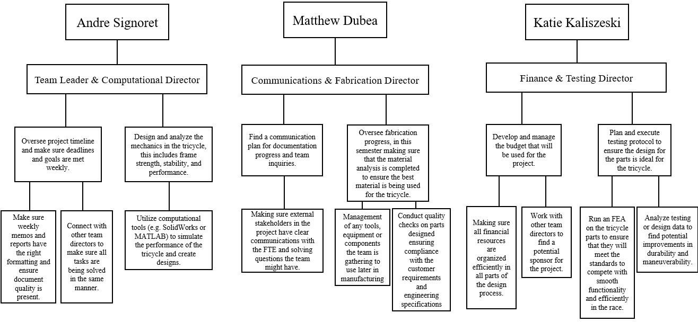

***Figure 14:*** Team Organization Flow Chart

# Facilities and Resources

The successful completion of this tricycle project was made possible by utilizing various facilities and resources at the university and in the community. Key resources included:

* **Machine Shop and Expertise:** The University’s Mechanical Engineering Machine Shop (Jeff Lab) was an indispensable resource. It provided access to heavy machinery such as CNC lathes, milling machines, drill presses, band saws, and welding equipment. Under the guidance of the lab supervisor (Mr. Jeff, the manufacturing lab instructor), the team was able to manufacture precision parts that would have been impossible with hand tools alone. Mr. Jeff’s expertise in machining and fabrication greatly accelerated the process – he assisted in setting up machines, selecting proper cutting tools, and ensuring safety procedures were followed. He also contributed creative solutions (as noted earlier, e.g. using a press-fit pin) drawn from his experience. The lab also supplied materials (4130, 4140 steel) and consumables like cutting fluid, welding rods, etc., which was a tremendous support. The team scheduled regular sessions in the lab and effectively collaborated such that one member might work on the lathe while another prepped the frame for welding, maximizing the use of the facility’s time. The machine shop also had measuring instruments (calipers, micrometers, gauges) that were used to verify part dimensions.
* **Design Software and Computing Resources:** The SolidWorks CAD software was a critical design tool. The university provided student licenses and computer labs where the team could model the tricycle in 3D and run simulations (FEA). This software enabled the House of Quality and Evaluation Matrix to be digitized as well. Additionally, some calculations and documentation were done using MATLAB and Microsoft Excel for quick computations and organizing data (for instance, calculating the Evaluation Matrix and HOQ score, doing unit conversions, etc.). The availability of these computational tools allowed the team to iterate the design virtually before cutting any metal, thereby reducing waste and design errors. The FEA module in SolidWorks was particularly useful to simulate loads that would be hard to test until the trike was built.
* **Advisors and Mentors:** The project was completed as part of the Senior Project (MCHE 482/484), with faculty such as Mr Jeff included. The faculty advisor (Dr. Yonas Niguse) provided periodic feedback on the project, ensuring the team held academic standards in weekly memo presentations. The event coordinator, Mrs. Hanna Pellerin, was available 24/7 to answer questions about race specifics and offered advice from past events. She stressed design compliance and gave tips like bringing spare parts on race day.
* **Tools:** Besides the lathe machine, the team also used smaller personal workshop tools like angle grinders, sanders, saws, hand drills, , files, wrenches, etc., for tasks like cutting the frame and assembling parts. A hydraulic press in the lab was used for the bushing installation near the front forks.
* **Testing Space:** For testing the assembled trike, the team made use of a campus parking lot and the engineering building courtyard. This gave space to ride and evaluate performance safely away from traffic. Cones were set up to simulate turning conditions. Having a safe testing area allowed the team to practice rider exchanges and confirm handling characteristics in an environment similar to the actual race track.
* **Human Resources (Team Coordination):** Although the report avoids first-person narrative, it’s worth noting that the project was carried out by multiple team members each taking on roles such as team lead, fabrication lead, finance, and testing coordinator. This internal organization (detailed in the original team charter) ensured that responsibilities like scheduling machine shop time, managing the budget, writing reports, and preparing presentations were all covered. Regular team meetings and documentation (weekly memos) kept the project on track. In effect, the **team itself** was a resource – combining different skill sets (one member might be more skilled in CAD, another in welding, etc.) led to a more efficient process. This collaboration with clear communication meant, for example, that while one member worked on FEA, another could be arranging material pickup, thereby parallelizing efforts.
* **External Resources:** The team engaged with external vendors minimally due to cost concerns, but where needed, they leveraged them wisely. The front wheel purchase was done from a

reputable vendor to ensure quality. The local bicycle shop was an external resource tapped for advice (they advised on the type of coaster brake to use and gave a spare part or two). Also, literature and past project reports were resources: research papers on bicycle dynamics and material selection (some referenced in the midterm report) provided background knowledge that guided decisions like material choices and geometric design for stability.

In conclusion, the combination of on-campus facilities, knowledgeable personnel, and strategic external inputs formed a robust support system for the project. The Fast Pedal Engineers effectively utilized the available resources: the fabrication infrastructure turned the paper design into a physical product, and the academic and community network ensured that best practices were followed. There were no significant resource shortages; any potential gaps (like needing a particular machine) were addressed ahead of time by adjusting the design or schedule. The project not only produced a tricycle but also served as a valuable learning experience in leveraging engineering resources efficiently, a key outcome for the future careers of the FPE.

### Race Results and Performance Summary

The Fast Pedal Engineers’ performance in the 2025 Acadiana 500 Tricycle Race demonstrated the success of the team’s engineering, fabrication, and preparation efforts. The team competed in a series of five rounds—two qualifiers, a semifinal, a final, and a championship race achieving exceptional results across all heats. The tables attached next provide some information on 4/5 races the FPE team competed in:

***Table 6:*** FPE Acadiana 500 Race Results

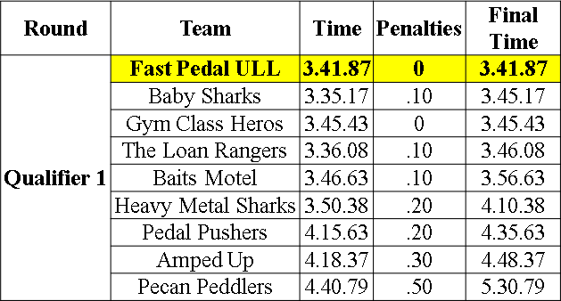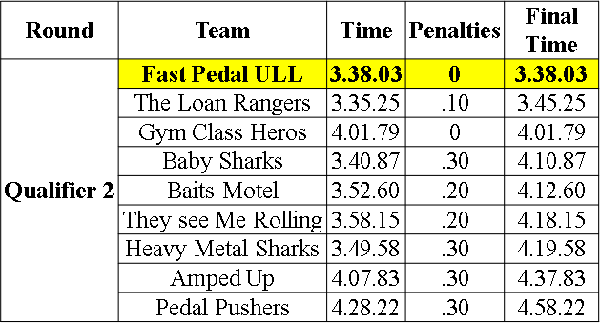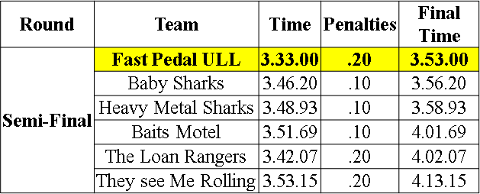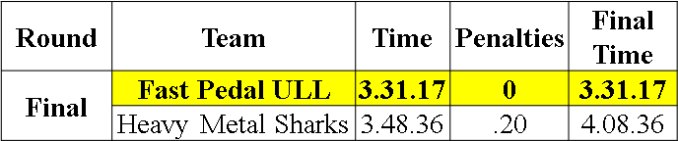

Some key performance highlights from the race include:

* Achieved **1st place overall**, winning all race rounds the team competed in.
* Recorded the **fastest track time of the day** at 3 minutes 31 seconds.
* Received **the fewest penalties** among all competitors, the FPE team also completed **4/5 races penalty-free.**
* Reached an **average team speed of 11.3 mph**, reflecting the effectiveness of the lightweight and rigid design.

The final event concluded with the Fast Pedal Engineers raising the championship trophy, marking the culmination of two semesters of design, fabrication, and testing. This achievement shows the importance that the design methodology and materials selection had on the tricycle, but also showcases the importance of teamwork and preparation. The image below shows the FPE team after the trophy ceremony on race day.

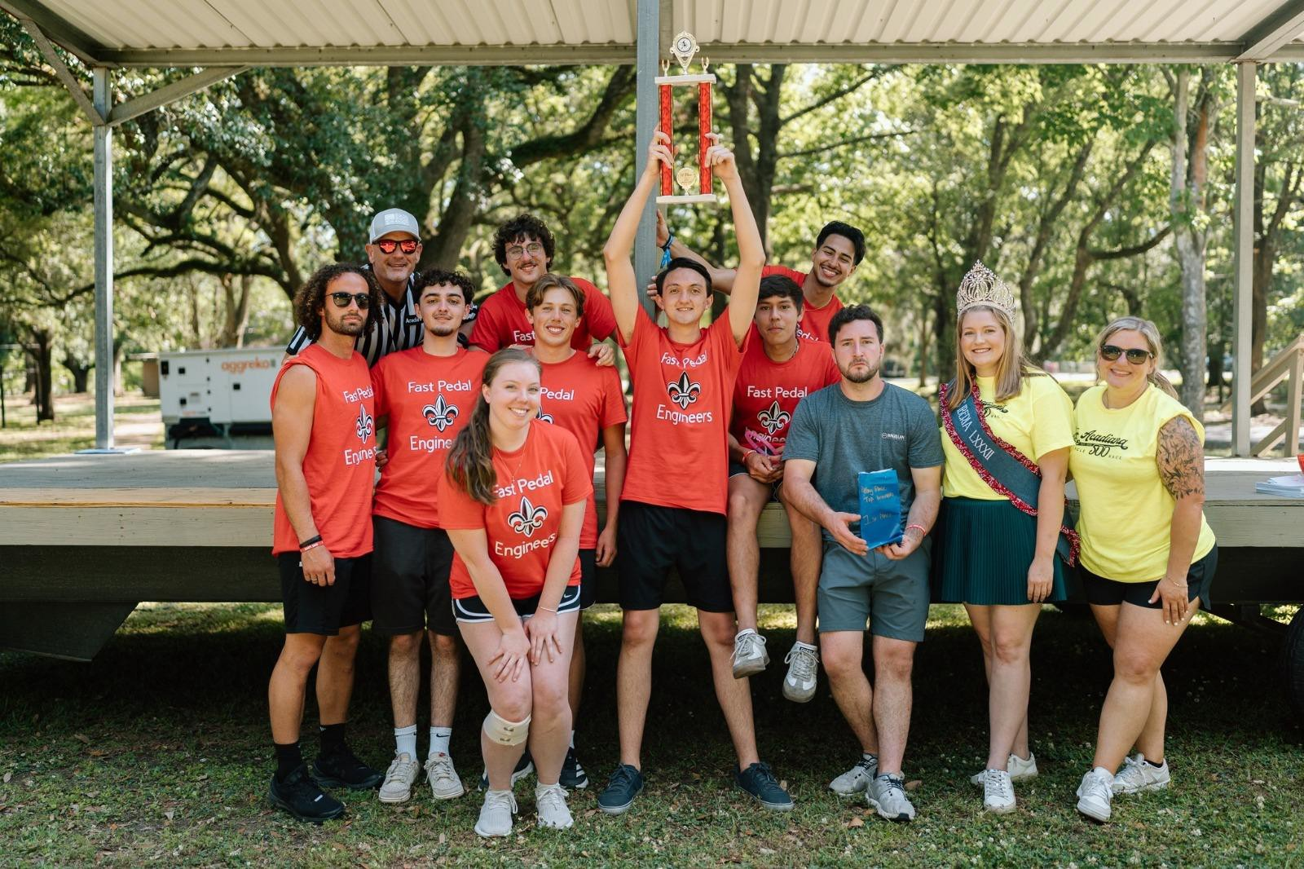

***Figure 15:*** FPE Trophy Ceremony

# 9. References

1. Acadiana 500 Race Rules. (2024). Acadiana 500 – Official Race Rules. Retrieved from [PDF file].
2. Acadiana 500 Sponsor Information. (2024). Acadiana 500 Tricycle Race Sponsorship Opportunities. Retrieved from [PDF file].
3. Acadiana 500 Tricycle Race. (2024). Acadiana 500 Tricycle Specification Sheet. Retrieved from [PDF

file].

1. Brown, D., & Miller, R. (2019). *Engineering principles in bicycle design: Dynamics and material selection*. *International Journal of Mechanical Engineering Education*, 47(3), 222-234.
2. Smith, J., & Andrews, L. (2021). *Structural analysis and optimization in tricycle design for durability and performance*. *Journal of Transportation Engineering*, 147(10), 04021118.
3. Martin, P., & Nguyen, H. (2020). *Material science considerations in engineering applications: Aluminum and steel in load-bearing frames*. *Materials Science and Engineering*, 557, 89-99.
4. MatWeb, LLC. *Material Property Data.* MatWeb, [www.matweb.com](http://www.matweb.com/). May 2025.
5. Garcia, M., & Tran, S. (2023). *Finite Element Analysis (FEA) for small-scale mechanical systems: Applications in vehicle design*. *Journal of Applied Engineering Research*, 71(1), 45-58.

# Appendix

|  |  |
| --- | --- |
| **Color** | **Key** |
|  | Completed |
|  | In-Progress |
|  | Phase 1 (Fall 2024) |
|  | Phase 2 (Spring 2025) |
|  | Racing Week |

***Figure 16****:* Color Key Utilized for Gantt Chart

|  |  |  |  |  |  |  |  |  |  |  |
| --- | --- | --- | --- | --- | --- | --- | --- | --- | --- | --- |
| **Week** | **1** | **2** | **3** | **4** | **5** | **6** | **7** | **8** | **9** | **10** |
| Finalize group, established team name, and assigned roles for all members |  |  |  |  |  |  |  |  |  |  |
| Establish means of communication |  |  |  |  |  |  |  |  |  |  |
| Meet with Hanna Pellerin |  |  |  |  |  |  |  |  |  |  |
| Research on tricycle designs, best materials to utilize, and how wheels size impacts acceleration, stability, and top speeds |  |  |  |  |  |  |  |  |  |  |
| Rough draft for a parts list |  |  |  |  |  |  |  |  |  |  |
| Team meeting |  |  |  |  |  |  |  |  |  |  |
| Receive SolidWorks Weld course |  |  |  |  |  |  |  |  |  |  |
| Sketch front tire to add to assembly |  |  |  |  |  |  |  |  |  |  |
| Create table to show optimal dimensions for tricycle performance |  |  |  |  |  |  |  |  |  |  |
| Design development on front axle of tricycle created on SolidWorks |  |  |  |  |  |  |  |  |  |  |
| Finalize parts in SolidWorks (create assembly) |  |  |  |  |  |  |  |  |  |  |
| Find sponsor |  |  |  |  |  |  |  |  |  |  |
| Perform FEA analysis on SolidWorks |  |  |  |  |  |  |  |  |  |  |
| Finalize each design |  |  |  |  |  |  |  |  |  |  |

***Figure 17:*** Phase 1 Gantt Chart Portraying Fast Pedal Engineers’ Schedule

|  |  |  |  |  |  |  |  |  |  |  |  |  |  |  |  |  |
| --- | --- | --- | --- | --- | --- | --- | --- | --- | --- | --- | --- | --- | --- | --- | --- | --- |
| **Week** | **11** | **12** | **13** | **14** | **15** | **16** | **17** | **18** | **19** | **20** | **21** | **22** | **23** | **24** | **25** | **26** |
| Meet with Hanna Pellerin to discuss phase 2 plan |  |  |  |  |  |  |  |  |  |  |  |  |  |  |  |  |
| Source all parts to order |  |  |  |  |  |  |  |  |  |  |  |  |  |  |  |  |
| Verify all parts being ordered with Hanna Pellerin |  |  |  |  |  |  |  |  |  |  |  |  |  |  |  |  |
| Purchase all unmanufacturable materials |  |  |  |  |  |  |  |  |  |  |  |  |  |  |  |  |
| Meet with Mr. Jeff to discuss required manufactured parts and machining process |  |  |  |  |  |  |  |  |  |  |  |  |  |  |  |  |
| Create new parts, using SolidWorks, necessary for updates to be made to tricycle model |  |  |  |  |  |  |  |  |  |  |  |  |  |  |  |  |
| Create new SolidWorks drawing of edited tricycle design |  |  |  |  |  |  |  |  |  |  |  |  |  |  |  |  |
| Meet with Mr. Jeff to manufacture parts |  |  |  |  |  |  |  |  |  |  |  |  |  |  |  |  |
| Perform FEA on SolidWorks design |  |  |  |  |  |  |  |  |  |  |  |  |  |  |  |  |
| Participate in local news interview |  |  |  |  |  |  |  |  |  |  |  |  |  |  |  |  |
| Drive to New Iberia to visit location of race |  |  |  |  |  |  |  |  |  |  |  |  |  |  |  |  |
| Finalize all manufactured parts with Mr. Jeff |  |  |  |  |  |  |  |  |  |  |  |  |  |  |  |  |
| Work on final presentation, poster, & report |  |  |  |  |  |  |  |  |  |  |  |  |  |  |  |  |
| Practice riding tricycle at race location |  |  |  |  |  |  |  |  |  |  |  |  |  |  |  |  |
| Make any necessary adjustments before the event |  |  |  |  |  |  |  |  |  |  |  |  |  |  |  |  |
| Final meeting with Hanna Pellerin to give final update |  |  |  |  |  |  |  |  |  |  |  |  |  |  |  |  |
| Prepare for final race |  |  |  |  |  |  |  |  |  |  |  |  |  |  |  |  |
| Race in final event! |  |  |  |  |  |  |  |  |  |  |  |  |  |  |  |  |

***Figure 18****:* Phase 2 Gantt Chart Portraying Fast Pedal Engineers’ Schedule

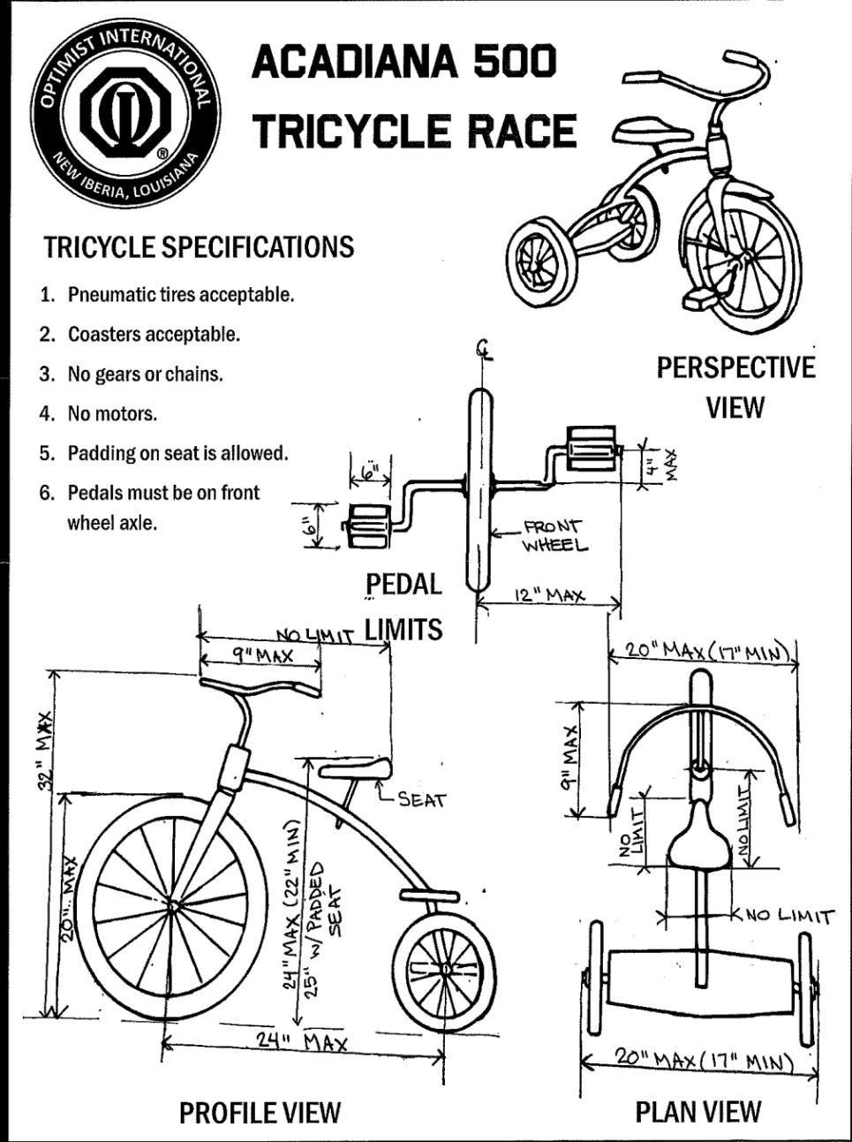

***Figure 19:*** Acadiana 500 Race Rules and Design Constraints

***Table 7****:* Tricycle Sub Assembly Breakdown and Analysis

|  |  |  |  |  |  |  |  |  |  |
| --- | --- | --- | --- | --- | --- | --- | --- | --- | --- |
| **Sub Assembly** | **Components** | **Qty** | **Material** | **Mass (lb)** | **Fab. process** | **Key Specs.** | **Source** | **Actual $** | **Market**  **$** |
| **Frame & Structure** | Main frame | 1 | 1018  tube | 9.5 | TIG | TIG-  welded donor | Re- used | 0 | 35 |
|  | Side stiffeners | 2 | 1018  plate | 2.5 | TIG | ¼ in gussets | In- house | 0 | 8 |
| **Front Axle** | 20" tire + hub  + 4" crank + coaster | 1 | Steel Hub/Coa ster, Al  Rim, | 12.1 | Purchased | coaster + arms | Purcha sed | 35 | 35 |
|  | Stem  extension | 1 | 1018 | 4.70 | CNC-turn  + TIG | +7 in, Ø1  in | Jeff lab | 0 | 20 |
|  | Head-set  screw | 1 | 10.9  alloy | 0.19 | Std | M10 × 1 | Re-  used | 0 | 1 |
|  | Handle-bars | 1 | 6061-T6 | 0.84 | — | 9 in width | Re- used | 0 | 25 |
| **Steering Mechanism** | Handle-bar grips | 2 | Rubber | 0.24 | — | 130 mm | Purcha sed | 12 | 12 |
|  | Pedals (pair) | 2 | Steel/Alu | 0.66 | — | ½-20, 4 in  crank | Purcha  sed | 28 | 28 |
|  | Banana seat | 1 | Vinyl/ste  el | 1.4 | — | 460 × 115  mm | Purcha  sed | 45 | 45 |
|  | T-piece (under seat  support) | 1 | 6061-T6 | 0.55 | CNC-mill | Ø1.25 × 3  in | Jeff lab | 0 | 18 |
| **Seat** |  |  |  |  |  |  |  |
|  | Seat spacers  + bolts | 1 set | Alloy | 0.25 | — | M8, ¼ in | Incl.  kit | 0 | 3 |
|  | Rear support  rods | 2 | 1018  tube | 0.7 | Cut + TIG | Ø½ × 15 in | Purcha  sed | 0 | 6 |
|  | Center Tube | 1 | 4130 | 0.73 | CNC-turn | 11.3 L ×  1.25 OD ×  1.13 ID ±  0.002 in | Jeff lab | 0 | 22 |
| **Rear Axle** | Axle Bushings | 1 | 4130 / C360 | 4 | CNC +  press-fit + heat treated | stepped Ø0.385 in | Jeff lab | 0 | 40 |
|  | Brass spacers | 2 | C360 | 0.16 | CNC-turn | Ø1.25 ×  0.25 in | Jeff lab | 0 | 6 |
|  | Center Frame Bushing | 2 | 1018 | 0.9 | CNC-turn | Ø1.80 OD  × 1.25 ID ×  0.25 t in | Jeff lab | 0 | 8 |
| **Total** | |  |  | **39.4** |  |  |  | **$120** | **$312** |

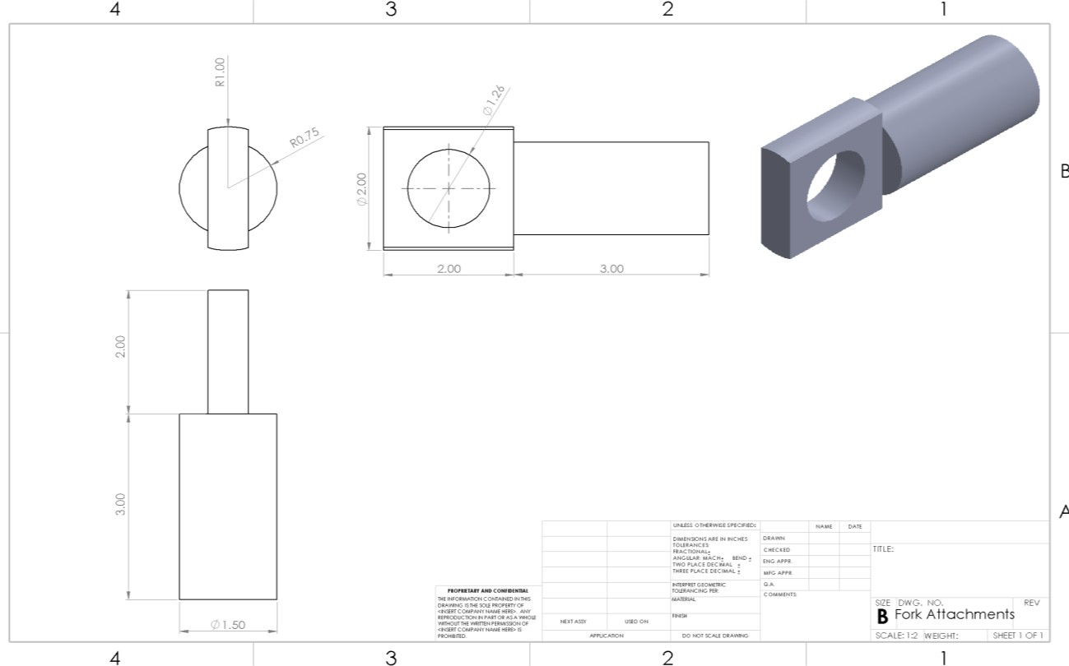

***Figure 20:*** Front Fork Attachment SolidWorks Drawing

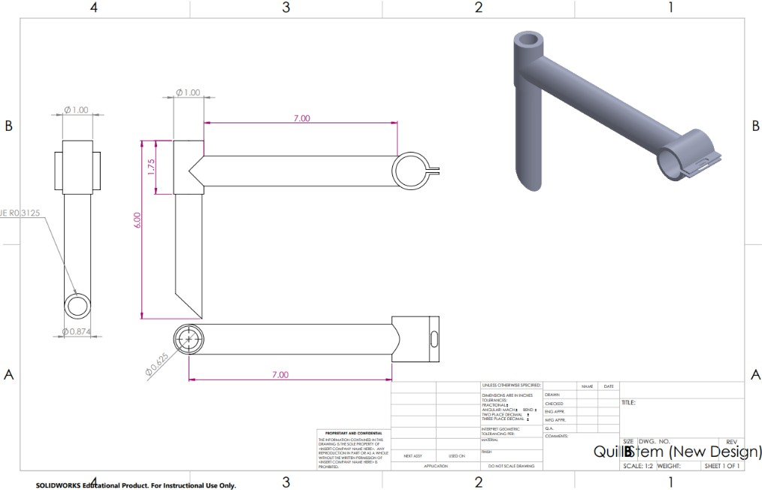

***Figure 21:*** Quill Stem SolidWorks Drawing

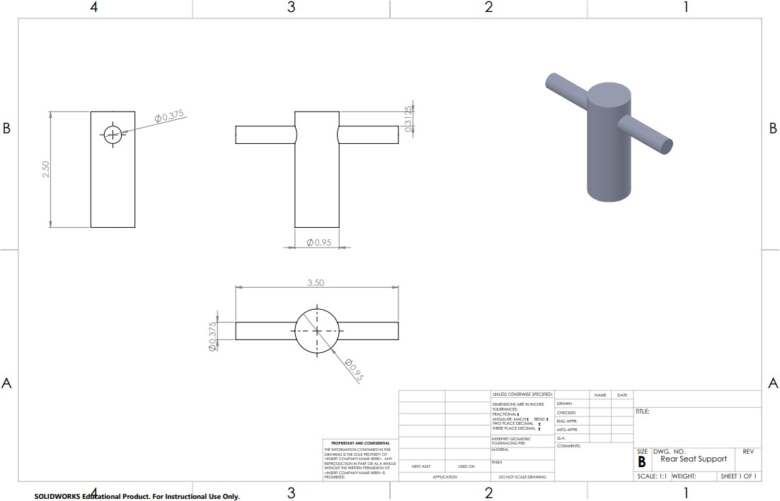

***Figure 22:*** Rear Seat Support SolidWorks Drawing

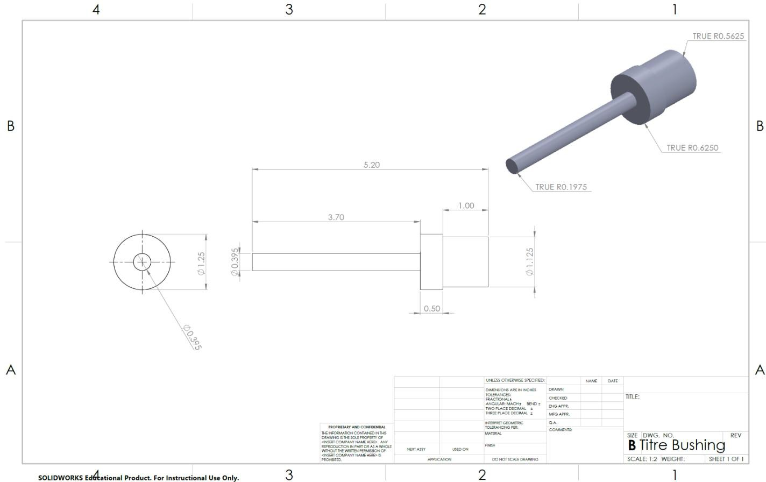

***Figure 23:*** Rear Axle Tire Bushing SolidWorks Drawing

# Sample Calculations

|  |  |  |  |  |  |  |  |
| --- | --- | --- | --- | --- | --- | --- | --- |
| **Component(s)** | **Material** | **UTS (psi)** | **Yield Strength (psi)** | **Machinability (% 1212)** | **Weldability** | **Density (lb/in³)** | **Weight (lbs)** |
| (Reused) Frame, Fork, Stem, Handlebars | AISI 1020 Steel | 60900 | 50800 | 65% | Excellent – welds easily | 0.284 | 13 |
| Rear Axle Tube | AISI 4130 Steel | 81200 | 66700 | 72% | Very good – no special procedure | 0.284 | 3 |
| Rear Axle Center Bushings | AISI 1018 Steel | 63800 | 53800 | 78% | Excellent – high-quality welds achievable | 0.284 | 0.3 |
| Rear Axle Stub (Wheel Bushing) | AISI 4140 Steel (Heat Treated) | 148000 | 95000 | 77% | Moderate – requires pre/post‑heat | 0.284 | 0.5 |
| Spacers | UNS C36000 Brass (Free‑Cutting Brass) | 55100 | 44200 | 100% | Not weldable; solderable | 0.307 | 0.16 |
| Fasteners | SAE J429 Grade 5 Steel | 120000 | 92000 | 65% | Not welded in design | 0.284 | 0.25 |
| Handlebar Grips | Natural Rubber (Vulcanized NR) | 4060 | — | — | — | 0.0343 | 0.24 |
| Rear Tires | Tire Rubber Compound (NR blend) | 4060 | — | — | — | 0.0343 | 5.4 |

***Table 8****:* Symbol and Equation Key

|  |  |  |  |
| --- | --- | --- | --- |
| **Symbol** | **Meaning / Description** | **Units** | **Typical Value or Notes** |
| m | Mass | kg / lbm | Used for trike, rider, or combined |
| W | Weight | N / lbf | W = m × g |
| g | Gravitational acceleration | 9.81 m/s² / 32.174 ft/s² | Standard gravity |
| v | Velocity | m/s / ft/s | Used in kinetic energy, speed calc |
| t | Time | s | Lap time |
| L | Lap Length | ft / m | One lap: 3485 ft |
| vavg | Average speed | ft/s | vavg = L / t |
| KE | Kinetic Energy | J / ft·lbf | KE = 0.5 × m × v² |
| Wmech | Mechanical Work | J / ft·lbf | W = P × t |
| P | Power output | W | Assum 84 W @ continuous effort |
| θtip | Tip-over angle | deg | θ = atan(b/2 / h) |
| ay | Critical lateral acceleration | ft/s² / g | ay = g × tan(θtip) |
| R | Turn radius | ft | Used in lateral speed calc |
| vmax | Max speed before tipping | ft/s / mph | vmax = √(ay × R) |
| C | Wheel circumference | in / ft | C = π × D |
| D | Wheel diameter | in | 20 in front |
| N | Pedal RPM | rev/min | N = v / (C × 60 / 88) |
| τ | Shear Stress | psi | τ = V / A |
| A | Cross-sectional Area | in² | A = π × d² / 4 |
| σb | Bending Stress | psi | σ = M / S |
| S | Section modulus | in³ | S = π × d³ / 32 |
| M | Bending moment | lbf·in | M = V × L / 2 |
| δ | Deflection (beam) | in | δ = WL³ / (3EI) |
| E | Young’s Modulus | psi | Material stiffness |
| I | Moment of inertia | in⁴ | Based on beam geometry |
| σvm | Von Mises Stress | psi | √(σ² + 3τ²) |
| σy | Yield Stress | psi | Material property |
| FoS | Factor of Safety | — | σy / σvm |
| θ | Angle | deg | Trigonometry |

### Mass, Weight, and Velocity

This step establishes the total weight of the combined rider and tricycle system, which is critical for calculating forces, inertial loads, and designing for structural requirements such as axle loading, tipping, and acceleration capabilities.

𝑊𝑡𝑜𝑡𝑎𝑙 = 𝑚𝑡𝑜𝑡𝑎𝑙 × g = 209.4 lbm × 32.174 ft/s² = 209.4 lbf

𝑊𝑡𝑜𝑡𝑎𝑙 ≈ 932 N (mass ≈ 95.0 kg)

### Average Course Speed

Average speed helps characterize rider cadence requirements, tricycle travel efficiency, and realistic system performance during a full lap on the 3485 ft track.

L = 3,485 ft, t = 211 s

𝑣𝑎𝑣𝑔

= 𝐿 = 3,485 / 211 = 16.5 ft/s = 11.3 mph

𝑡

### Wheel Rotations per Lap

Knowing the total number of revolutions per lap informs pedal rotation frequency, drivetrain expectations, and torque-cadence matching for efficient rider power output.

C = π·D = π·20 in = 62.83 in = 5.24 ft

𝑁 = 𝐿 = 3,485 ≈ 665 rev

𝑟𝑜𝑡

𝐶 5.24

### Kinetic Energy & Mechanical Work

Kinetic energy reflects the dynamic load potential at race pace. Mechanical work estimates how much energy the rider must exert per lap—crucial for evaluating fatigue, drivetrain efficiency, and required power.

KE = 0.5 × (209.4 / 32.174) × (16.5)² = 886 ft·lbf ≈ 1.20 kJ W = 84 W × 211 s ≈ 17.7 kJ

### Tip-Over Analysis & Critical Lateral Acceleration

This analysis provides a quantitative understanding of how far the trike can lean before instability. The critical lateral acceleration helps assess cornering safety margins.

b = 19.5 in = 1.625 ft,

h = 23 in = 1.92 ft

𝜃𝑡𝑖𝑝 = atan((b/2)/h) = atan(0.812/1.92) ≈ 23°

𝑎𝑦(𝑚𝑎𝑥) = g·tan(𝜃𝑡𝑖𝑝) = 32.174 × tan(23°) ≈ 13.6 ft/s² ≈ 0.42 g

### Maximum Safe Turning Speed

This ensures that under full lean, the tricycle won’t exceed its tipping limits while cornering sharply. Helps validate safe turning radii during high-speed maneuvering.

R = 15 ft

𝑣𝑚𝑎𝑥 = √ (𝑎𝑦×R) = √ (13.6×15) ≈ 14.3 ft/s = 9.8 mph

### Pedal Cadence and Top Speed

Mapping cadence to vehicle speed helps size crank arms appropriately and match expected rider effort to achievable pace.

C = 5.24 ft,

v(mph) = 0.357 × 𝑁𝑟𝑝𝑚

v = 11.3 mph → N ≈ 32 rpm v = 14.5 mph → N ≈ 41 rpm

### Rear Axle – Shear & Bending Stress

Critical to confirm that the custom-machined axle can sustain peak race loads without failure. Validates our use of 4140 steel and confirms yield margin.

|  |  |  |  |
| --- | --- | --- | --- |
| d = 0.385 in | A = 0.116 in² | S = 0.0149 in³ | V = 104.7 lbf |
| L = 11.3 in | τ = 903 psi | M = 592 lbf·in | σb = 39.7 ksi |

Von Mises: √(σb² + 3τ²) ≈ 39.7 ksi

𝐹𝑜𝑆𝑎𝑥𝑙𝑒

= 69

39.7

≈ 1.7

### Seat Post Deflection

Ensures the cantilevered seat remains within acceptable deflection bounds for both comfort and durability. Excess flex would cause discomfort and instability.

W = 85 lbf L = 7 in E = 29e6 psi I = 0.049 in⁴

δ = 𝑊×𝐿3

3×E×I

= 0.062 in < 0.25 in spec

### Frame FEA – Safety Margin Verification

This is the final safety margin check from the simulated structural stress testing. It ensures salvaged steel frame design will not yield under racing conditions.

𝜎𝑣𝑚 = 2.795×10⁸ N/m²,

𝜎𝑦 = 6.204×10⁸ N/m²

FoS = 𝜎𝑦 = 6.204𝑒8 = 2.22

𝜎𝑣𝑚

2.795e8